MATCH SCHEDULE
FRIENDLY MATCHES Tuesday 4th July

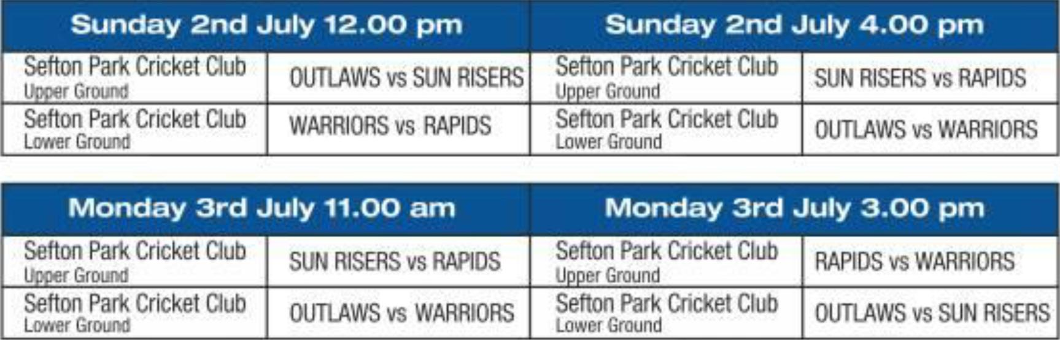
Sunday 2nd July 4.00 pm
Sunday 2nd July 12.00 pm
OUTLAWS vs SUN RISERS
SUN RISERS vs RAPIDS
OUTLAWS vs WARRIORS
WARRIORS vs RAPIDS
Sefton Park Cricket Club
Sefton Park Cricket Club
L2.4er GroLr:
Sefton Park Cricket Club
Lower Ground
Monday 3rd July 11.00 am
Monday 3rd July 3.00 pm
SUN RISERS vs RAPIDS
Sefton Park Cricket Club RAPIDS vs WARRIORS
Upper Ground
Sefton Park Cricket Club
Lower Ground
OUTLAWS vs WARRIORS
Sefton Park Cricket Club
Lower Ground
OUTLAWS vs SUN RISERS
Sefton Park Cricket Club
Grw,r-r!,
SEFTON PARK CRICKET CLUB UPPER GROUND
10.00 am Sunrisers/Wellington School, Somerset Vs Zimbabwe Rising Stars (20 overs match)
1.30 pm Mersey Cricket Foundation Select 11 Vs Zimbabwe Rising Stars (40 overs match)

Wednesday 5th July 11.00 am
Wednesday 5th July 3.00 pm
Sefton Park Cricket Club
Upper Ground
OUTLAWS vs RAPIDS
Sefton Park Cricket Club OUTLAWS vs WARRIORS
Upper Ground
Sefton Park Cricket Club Lower Groom!
ALL STARS vs WARRIORS
Sefton Park Cricket Club
Lower Ground
ALL STARS vs RAPIDS
Thursday 6th July 11.00 am
Thursday 6th July 3.00 pm

Sefton Park Cricket Club Upper Ground
SEMI FINALS 1st V 4th Sefton Park Cricket Club FINALS
Upper Ground

Sefton Park Cricket Club
Lower Ground
SEMI FINALS 2nd V 3rd
Sefton Park Cricket Club Play offs 3rd v ^{4th}Lower Ground

