L&DCC Club & Grounds
Site Visits
2022

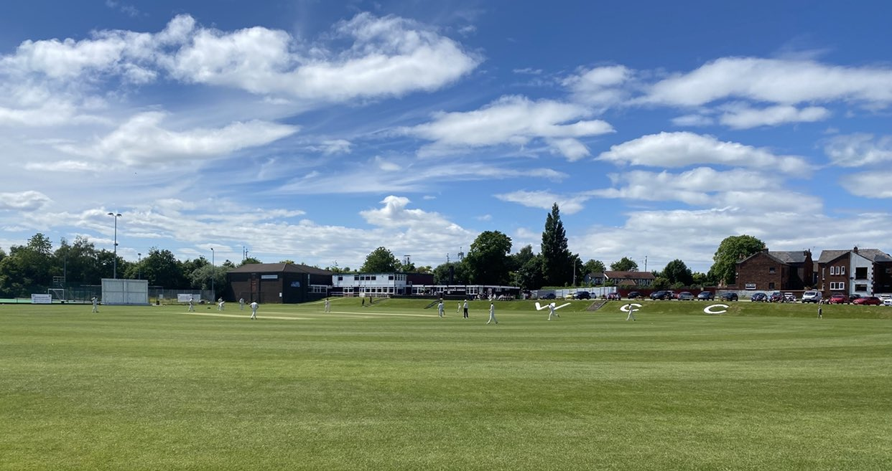

J S Hathaway – 10 Dec 22

1. Introduction

1.1 As part of its commitment to maintaining ECB Premier League status, the L&DCC are required to fulfil an annual programme of site visits to ensure that club and ground facilities are being maintained in accordance with the standards that the ECB require.

1.2 In order to fulfil this commitment, the L&DCC appoint a Chairman of
Club & Grounds, Jim Hathaway, and it is his duty to inspect selected grounds on a seasonal basis. All clubs receive a visit on at least a bi-annual basis.

2. Site Visits – 2022

2.1 The following grounds were visited in 2022 and the marks awarded can be seen below:

Liverpool & District Cricket Competition
Club & Grounds Visits - 2022
Serial | Club | Date Visited | % | Assessor
1 | Wigan | 21-May-22 | 98% | Hathaway
2 | Colwyn Bay | 23-Jul-22 | 97% | Hathaway
3 | Ormskirk | 20-Jul-22 | 97% | Hathaway
4 | Leigh | 26-Jun-22 | 97% | Hathaway
5 | Northern | 16-May-22 | 97% | Hathaway
6 | Sefton Park | 04-Jun-22 | 96% | Hathaway
7 | Maghull | 13-Aug-22 | 95% | Hathaway
8 | Birkenhead Park | 25-Jun-22 | 94% | Hathaway
9 | Ainsdale | 14-Jul-22 | 93% | Hathaway
10 | Wavertree | 02-Jul-22 | 93% | Hathaway
11 | Alder | 31-Jul-22 | 80% | Hathaway

3. Executive Summary

3.1 Further to the site visits, all clubs receive a fully detailed numerical breakdown of all areas of the ground and facilities that are assessed, and this is supported by an Executive Summary. During the visits it is abundantly clear that all clubs demonstrate a quantifiable and identifiable commitment to club and grounds maintenance and each club is a credit to the L&DCC, themselves and the communities that they support.

3.2 All clubs were reasonably consistent in the scoring for the core elements of the grounds inspection; however, the differentiation that is demonstrated is attributable, in the main, to the specific umpire marks that were awarded for the day of the match that the inspection took place.

3.3 Notwithstanding the above point, Alder clearly represents an outlier for this year; however, after further discussions with the Alder CC Chairman, the Club has a major capital works programme that is being worked up in conjunction with a local property developer and, if this programme of works is realised, then Alder CC have a spectacular new development to look forward to. As a word of caution to Alder, should the works be delayed then I would strongly recommend that the observations that were raised on the 2022 report are addressed, as far is possible, prior to the commencement of the 2023 season.

3.4 Whilst cricket faces many challenges in the form of additional bureaucratic requirements and questionable player behaviour, the Club & Ground Site visits remind me of the values that we hold dear to our heart in supporting our sport. Without exception the hospitality, cooperation and support that I received from groundsmen, umpires, captains, players, club officials and spectators was exceptional and I express my sincere thanks to everyone involved in the clubs that I visited in 2022 for making this duty such a pleasure.

Jim Hathaway
L&DCC – Club & Grounds Officer

E-Mail: jim.hathaway126@outlook.com

Tel: 07894 124 165

10 Dec 22

