L&DCC
2022 Season
Review of Club Conduct Marks

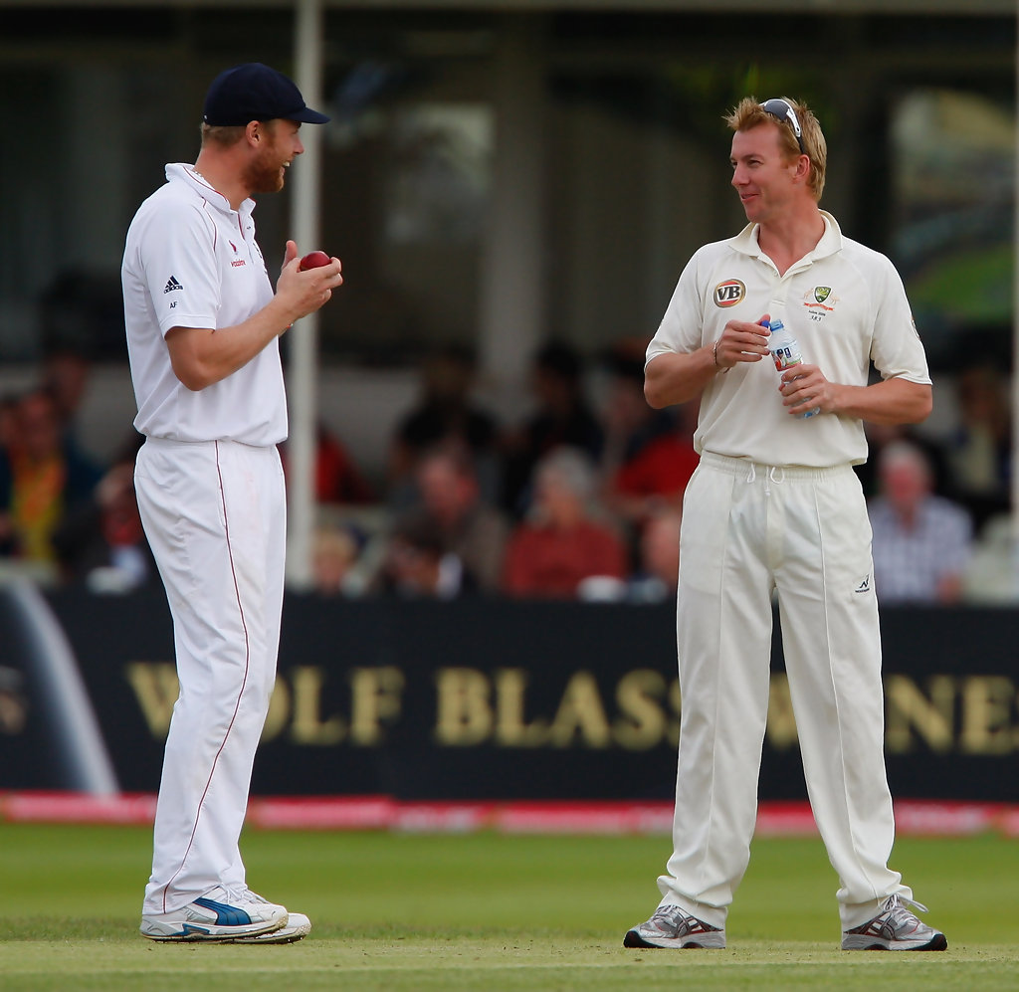

J S Hathaway – 10 Dec 22

1. Introduction

1.1 During the course of a discussion with a L&DCC Committee colleague at the early part of the 2022 season, I pointed out that I had noticed an identifiable downward trend in the overall conduct marks that clubs were being awarded on a weekly basis. My colleague then confirmed that, at that stage of the season, there had also been a noticeable escalation in the number of disciplinary reports that the League had received in comparison to previous years.

1.2 In light of this feedback, and after 2 or 3 years of procrastination, I decided to analyse the marks that were being awarded for all clubs, both home and away, to determine whether or not my instinct was correct or if it was just a result of my overactive imagination.

2. Findings

2.1 Based on the marks that are received from umpires, conduct marks fall into 8 categories, 4 for the conduct of the home team and 4 for the away team.

2.2 Each team is individually assessed and the tables below show the Executive Summary for each club covering the 2022 season:

 | Premier Division - Number of Occurrences (Per Question) - Conduct < 5 / 5
Team / Question | Q22  Home Team  Opponent Respect | Q24  Home Team  Umpire Respect | Q25  Away Team  Opponent Respect | Q26  Away Team  Umpire Respect | Q27  Home Captain  Team Control | Q28  Home Captain  Cooperation With Umpire | Q29  Away Captain  Team Control | Q30  Away Captain  Cooperation With Umpire | Club Total
Ormskirk | 6 | 3 | 2 | 2 | 3 | 1 | 0 | 0 | 17
Newton Le Willows | 3 | 3 | 1 | 1 | 4 | 2 | 1 | 1 | 16
Wallasey | 2 | 2 | 2 | 2 | 1 | 1 | 1 | 1 | 12
Birkenhead Park | 2 | 2 | 2 | 1 | 1 | 1 | 1 | 1 | 11
Rainhill | 2 | 2 | 1 | 1 | 1 | 0 | 1 | 3 | 11
Leigh | 5 | 1 | 2 | 1 | 0 | 0 | 0 | 0 | 9
Wigan | 1 | 1 | 2 | 2 | 1 | 1 | 1 | 0 | 9
Formby | 2 | 3 | 1 | 1 | 0 | 0 | 1 | 0 | 8
Orrell Red Triangle | 2 | 0 | 1 | 2 | 1 | 1 | 1 | 0 | 8
New Brighton | 1 | 1 | 1 | 0 | 0 | 0 | 0 | 0 | 3
Northern | 0 | 0 | 0 | 1 | 0 | 1 | 1 | 0 | 3
Southport & Birkdale | 0 | 0 | 0 | 0 | 0 | 1 | 0 | 0 | 1
Prem Totals | 26 | 18 | 15 | 14 | 12 | 9 | 8 | 6 | 108
Total 0 Occasions | 2 | 3 | 2 | 2 | 5 | 4 | 4 | 8 | 30

 | 1st Division - Number of Occurrences (Per Question) - Conduct < 5 / 5
Team / Question | Q22  Home Team  Opponent Respect | Q24  Home Team  Umpire Respect | Q25  Away Team  Opponent Respect | Q26  Away Team  Umpire Respect | Q27  Home Captain  Team Control | Q28  Home Captain  Cooperation With Umpire | Q29  Away Captain  Team Control | Q30  Away Captain  Cooperation With Umpire | Club Total
Ainsdale | 1 | 4 | 2 | 2 | 2 | 0 | 2 | 1 | 14
Liverpool | 2 | 1 | 0 | 3 | 2 | 1 | 2 | 1 | 12
Lytham | 1 | 1 | 0 | 2 | 1 | 1 | 2 | 2 | 10
Spring View | 1 | 1 | 2 | 1 | 1 | 1 | 1 | 1 | 9
Bootle | 1 | 1 | 2 | 1 | 1 | 0 | 1 | 0 | 7
Caldy | 0 | 1 | 0 | 2 | 1 | 1 | 1 | 1 | 7
Highfield | 0 | 1 | 1 | 0 | 1 | 0 | 0 | 0 | 3
Colwyn Bay | 0 | 0 | 2 | 0 | 0 | 0 | 0 | 0 | 2
Northop Hall | 0 | 0 | 1 | 1 | 0 | 0 | 0 | 0 | 2
Rainford | 1 | 0 | 0 | 0 | 1 | 0 | 0 | 0 | 2
Sefton Park | 1 | 0 | 1 | 0 | 0 | 0 | 0 | 0 | 2
Fleetwood Hesketh | 0 | 0 | 0 | 0 | 0 | 0 | 0 | 0 | 0
Div 1 Totals | 8 | 10 | 11 | 12 | 10 | 4 | 9 | 6 | 70
Total 0 Occasions | 5 | 5 | 5 | 5 | 4 | 8 | 6 | 7 | 45

 | 2nd Division - Number of Occurrences (Per Question) - Conduct < 5 / 5
Team / Question | Q22  Home Team  Opponent Respect | Q24  Home Team  Umpire Respect | Q25  Away Team  Opponent Respect | Q26  Away Team  Umpire Respect | Q27  Home Captain  Team Control | Q28  Home Captain  Cooperation With Umpire | Q29  Away Captain  Team Control | Q30  Away Captain  Cooperation With Umpire | Club Total
St Helens | 3 | 2 | 4 | 4 | 3 | 2 | 3 | 3 | 24
Hightown St Marys | 2 | 2 | 3 | 2 | 2 | 2 | 2 | 2 | 17
Alder | 1 | 2 | 3 | 3 | 2 | 1 | 2 | 2 | 16
Maghull | 3 | 2 | 2 | 1 | 2 | 2 | 2 | 0 | 14
Southport Trinity | 3 | 2 | 2 | 4 | 0 | 0 | 1 | 1 | 13
Norley Hall | 4 | 1 | 2 | 0 | 2 | 0 | 0 | 0 | 9
Parkfield Liscard | 1 | 1 | 2 | 1 | 1 | 1 | 1 | 1 | 9
Wavertree | 1 | 1 | 1 | 1 | 1 | 1 | 1 | 1 | 8
Sutton | 1 | 1 | 0 | 1 | 1 | 0 | 0 | 0 | 4
Prestatyn | 0 | 1 | 0 | 1 | 0 | 0 | 0 | 0 | 2
Old Xaverians | 0 | 0 | 0 | 0 | 0 | 0 | 0 | 0 | 0
Div 2 Totals | 19 | 15 | 19 | 18 | 14 | 9 | 12 | 10 | 116
Total 0 Occasions | 2 | 1 | 3 | 2 | 3 | 5 | 4 | 5 | 25

3. Conclusion

3.1 In a week when the ECB has seen fit to issue a 31 page document entitled Advance Notice on General Conduct in Recreational Cricket (A 31 page document) of which all clubs are to understand, adopt and apply, it is abundantly clear that based on my own instinct and the supporting data above, the L&DCC is indeed experiencing a decline in conduct standards that, if not addressed, will have significant and far reaching consequences on the way that we are able to deliver cricket.

3.2 All clubs are strongly urged to discuss the above data at their own forthcoming club committee meetings and the issue will be open for wider discussion at the forthcoming L&DCC AGM.

Jim Hathaway
L&DCC – Club & Grounds Officer

E-Mail: jim.hathaway126@outlook.com

Tel: 07894 124 165

10 Dec 22

