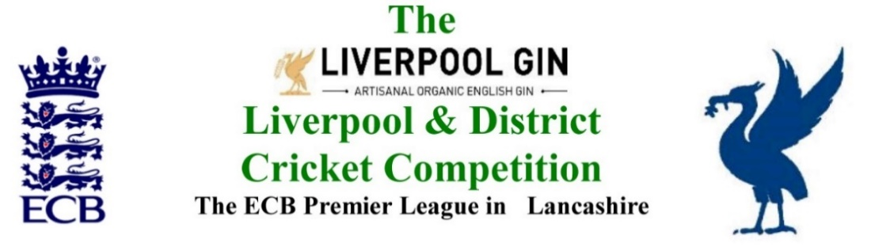
www.lpoolcomp.co.uk

M/C Meeting to be held at Bootle CC on Monday 26th Feb 2018 at 12.00 noon:

Agenda item | Recorded Minutes
Welcome to Jim Hathaway | JH was warmly welcomed to the meeting, he would be taking over the post of Club and Ground (C&G) Chair on a gradual basis starting with the Umpire’s Pitch Mark/Spirit of Cricket cards, from AB in 2018.
1.  Apologies:  12.55pm | - There were apologies from Eric Hadfield (President) who was on holiday in Australia. There were no further apologies as all six other officials were present:  John Williams (Chair) Chris Weston (Hon Sec); Rob Durand (1st & 2nd Team Fixture Secretary); Alan Bristow (Hon Treas); John Rotheram (Cricket Chair); Eddie Shiff (3rd XI Coordinator); Jim Hathaway (Club and Ground)
2.  Minutes: | - Signing of Previous Meetings  The Chair signed both the Dec 2017 and the Jan 2018 sets of minutes as true and accurate records of the meetings.  - Action Point Items  JW outlined the system to JH.  The Action Points were to be considered briefly as set out below and picked up in detail under agenda items as appropriate and necessary.  - Matters arising  These were to be taken largely en passant as they were covered by agenda items.
3.  Chairman's Remarks  3.  Chairman's Remarks | - Women’s Cricket Officer appointment  It was unanimously agreed that Paul Bate be appointed the L&DCC Women and Girls Officer.  - L&DCC/MCUA New Law Training Seminars  http://www.lpoolcomp.co.uk/management_bulletins.php?id=3063  The .ppt prepared by Hughie Evans looked very good.  New Laws Seminar (W) Mon 5th March New Brighton 7.30pm  New Laws Seminar (N) Mon 8th March S&B 7.30pm  New Laws Seminar (E) Mon 13th March N le W 7.30pm  New Laws Seminar (S) Mon 15th March Bootle 7.30pm  - MoU meeting with LCF 13/02/18 Old Trafford  The notes from this meeting had been circulated to M/C.  CW ran through the implications of MoU 2018 Priority Area 17 (“PA”) as previously discussed and copied.  - Feeder League Meeting 15/02/18 Bootle  This had gone well, the notes from the meeting had been circulated without dissent.  The Junior League had been the main topic of discussion.  - JCL 23 01 18 L&DCC / S&D ACL  As per the circulated notes the Liverpool Competition-Southport District-Junior League (LC-SD-JL had been set up at the Feeder League meeting to prevent it from collapsing. The L&DCC had taken over this league.  There were 4 Divisions in all; Under 18s (7 teams) U15s (9) U13s (9) and U11s (9), they played league and cup.  JW repeated that there would be no merging with the Merseyside Youth Competition in 2018.  - Echo meeting Dave Prentice 06/02/18  JW had spoken to Tom Evans from the Echo. See also Fixtures 7.16  - L&DCC Presentation Evening 2018 05/10/2018  We would leave this on the agenda for now. Cr Co had discussed the matter. “Try the suggested new format, then evaluate it” had been agreed there after discussion.  - Indoor League 2018 and 2019  2018 would be the last year we ran this for LCF. We had already decided that there would be no 2019.We would again lose money, most L&DCC clubs were demonstrably not interested in participating.  - Handbook 2018  CW had paused Handbook production with InPrint on Fri 23rd so that LC-SD-JL fixtures could go in, and two more MCUA umps be inserted.  - ECB to Leagues Data Protection Guidance  CW had been sent this “General Data Protection Regulation” guidance document (GPDG) by ECB via Paul Bedford, CW had circulated it to M/C. CW outlined that little that did understand of it based on a couple of read-throughs, he thought it would very easy to over react to it.
4.  Club & Ground Chair’s Report | - JH to assist EH/AB  There would be a transition process to ease JH into post. The first part of this would be JH taking over from AB/EH the receipt and processing of the umpire’s pitch marks and Spirit of Cricket marks in 2018.  - Overview of C&G  EH had already spoken to JH about this in outline, the process would be an on-going one.
5.  Hon Treasurer’s Report | - Figures of Account Jan/Feb 2018  Were given as at 26/02/2018:  AB also supplies copies of up to date bank statements from Bank of Scotland.  The statements were noted as being fully balanced.  5.1 Expenditure  5.1.1 St Bedes  Had been paid for the Indoor League so far in 2018.  5.1.2 LCF Fees  Club Fees in 2018 were now reported as being unchanged for 2018 being:  £125 for full LCF clubs  £50 for Affiliate Member clubs  £40 for non-Lancashire based member clubs.  5.2 Income  5.2.1 Subscription:  A subscription-cheque had been received but this had not yet been cashed.  5.2.2 PDP 2018  AB would incorporate costs for this and the Indoor League 2018 subscriptions into the Invoices to the clubs at the pre-season meeting.  - Purchase of Balls 2018  Boxes of Tiflex pink balls had been ordered plus  Boxes of Special County Imperial Crown red balls for Rep games and Finals  One box of 6 “Junior Balls” i.e. 4¾ oz balls was added to this order.  - Budget 2018 update  As promised this had been updated by AB and was ongoing, we seemed to be in good shape.
6. Registration Sec's Report | - Registrations Report RD update  RD reported that 10 were outstanding, 2 were received in the last few days.  - Dual Registrations  A club had requested 3 players for dual registration. The process had been explained to them.  - Moore & Smalley Palace Shield Competition. Luke Platt timing of 1-week ban left to be served now with Ormskirk.  It was agreed that this had to be during the first week of our season, it could not be applied to pre-season games.  - Updating Registration Regs over repeated re- registrations  RD drew attention to 6.3 P.72, the regulations barred re-registration through the use of the word “only” in 6.3 on the page-turn to P73 when defining those players that could re-register during the season.
7  Fixture Sec's Report | - 1st/2nd XI FS’ Report RD  The various “TBAs” were coming through and being dealt with.  - 3rd XIs League Coordinators Report  The new Wallasey 4th XI had been taken into 3rd XI Sunday SE.  - 1st XI Ray Digman Cup  Nothing was happening over the Cups – yet!  - 1st XI Ray Tyler Shield / Cup  - NatWest ECB T20  - 2nd XI Chester Cup  - 2nd XI Tittershill Shield/Cup  - Chrysalis Cup 2nd XI T20  - Mike Leddy Cup 3rd XI T40  - Embee Cup 3rd XI T20  - MCC Date/Game venue 07/08/2018 Sefton Park CC  SP CC was noted as having withdrawn from hosting any LCF junior games in 2018.  - Indoor League 2017/2018  - Rep games 2018 U12/14/18/21/All Age  The 12s and 14s fixtures were hoped for by next Wednesday, we would take it from there.  The L&DCC U16s would, as usual, play against the LCF U15s on Tues 22nd May in a “warm up” game for them, the venue was tba.  - ECB/LCB U19sT20 2018  No Central Entry portal 2018  - Brighton/Sussex touring side 2018  Sun 15th to Fri 20th July: Monday v Formby / Tues v Northern / Wed v Ormskirk/ Thur v L&DCC  - Echo Cup  JW had spoken to the Echo. How did they want us to act over the Echo Cup?  The Echo would put a piece in the paper inviting the 39 named clubs to take part again in 2018, their entry would be automatic, they could simply decline entry if they wanted to.. We would speak to the Cheshire CL and to the S&D ACL asking them to publicise this too.
8.  Cricket Chair’s Report | - Cr Co Report  M/C had possession of the Digman Cup and the associated medals from 2017 ready for the 2018 Final on 29th April.  - TCS and ECB PC-Pro-Scoring update.  The ECB Road Show was at Old Trafford on Tues 10th April
9.  Publicity & Sponsorship Chair’s Report | - Items not previously covered under Item 3  There was no report.
10.  Website matters | - Gud Design for 2018  No report  - JW was keeping the “players moving” article up to date on the website. It was a popular feature according to feedback
11.  Hon Secretary’s Report | - All items for the Hon Sec had been covered en passant
12.  LCB / ECB Issues | - LCF Update  There was no further information available.  - LCC Sat March 24th Nantwich CC  The details of this meeting had been circulated to M/C by CW.
13.  A.O.B. | - There no items of A.O.B.
14.  Date of Next Meeting | New Laws Seminar (W) Mon 5th March New Brighton 7.30pm CW to attend as M/C Rep  New Laws Seminar (N) Mon 8th March S&B 7.30pm JH/CW to attend as M/C Reps  New Laws Seminar (E) Mon 13th March N le W 7.30pm JR/CW to attend as M/C Reps  New Laws Seminar (S) Mon 15th March Bootle 7.30pm AB to attend as M/C Rep  Cr Co + ARSecs Mon 19th March Bootle 7.00pm  M/C Mon March 26th Bootle 1.00pm  Captain’s Evening Tues March 27th Bootle 5.30pm

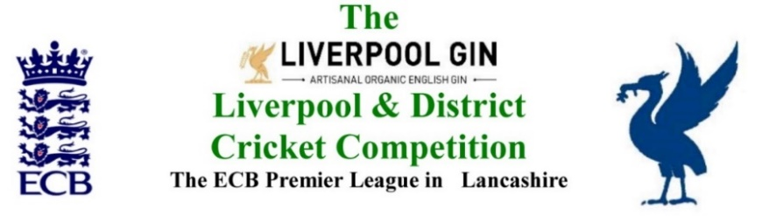
www.lpoolcomp.co.uk

The next meeting will be held at Bootle CC on Monday 26th February 2018 at 1.00 pm.

DRAFT

Agenda to include

- Apologies

- Minutes

- Chairman's Remarks

- Club & Ground Chair’s Report

- Hon Treasurer’s Report

- Registration Sec's Report

- Fixture Sec's Report

- Cricket Chair’s Report

- Publicity & Sponsorship Chair’s Report

- Website matters

- Hon Secretary’s Report

- LCB / ECB Issues

- A.O.B.

- Date of Next Meetings

