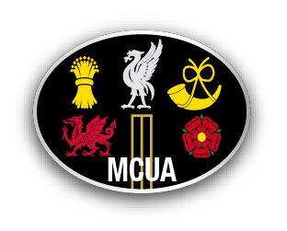
Welcome to Bootle CC and the MCUA AGM

Law Changes, Match Card Changes and Pitch Marking

MCC Law Changes

• MCC have made changes to the Laws which will be applicable from April 2019

• In total there are 22 changes

• Most of these changes will make no material difference to the game as it is played as they are minor corrections or clarifications

• But there are a few significant changes

• I have picked out the changes that you may come across

Law 21.12

The batting side will still get the benefit of a no-ball if there is deliberate distraction, deception or obstruction of the batsman

Law 37.3

Which ever batsman obstructs a fielder when there was a call of no-ball will be given out

Law 16.3.3 and Law 42.1

• Time lost in dealing with player misbehaviour will be added on to the scheduled close of play (i.e. from the calling of time to the calling of play)

• No overs will be deducted for time lost in the last hour

Law 41.2

• This Law has been rewritten

• Umpires can act if they consider that any action by a player, not covered by the Laws, is unfair

• The Law requires you to give the Captain a first and final warning that any further occurrence will result in penalty runs being awarded to the opposition

• It may be that the umpires together, as a way of helping to manage the match, decide to give an informal warning to the captain

• Discipline report if captain given a official ‘first and final warning’ • Report on match card any informal warning

Law 41.7

• From 1st April 2019, the Law allows umpires to make a more subjective decision over which full pitched above waist height deliveries are dangerous.

• Every delivery above waist height is a no-ball

• If not considered dangerous then no-ball and no further action.

• If dangerous then no-ball and first and final warning. (Any further such delivery then remove from attack)

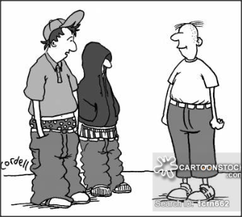
Appendix A - A6.7

• For the first time, the MCC have included within the Laws a definition of waist height.
• Waist height is defined as the point at which the top of the batsman’s trousers would conventionally be when he/she is standing upright at the popping crease.

Law 41.16

• The non- striker out of his ground when a bowler breaks the stumps in his delivery stride, with his hand holding the ball, can be given out on appeal

Details of all the Law changes can be found on the MCC web site, address below or by using the link on the MCUA web site

https://www.lords.org/lords/news-stories/mcc-announce-changes-to-the-new-code-of-laws-from

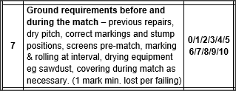

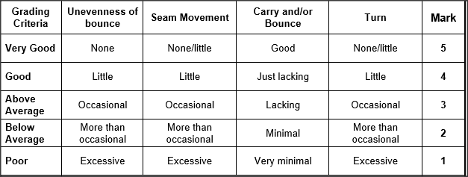

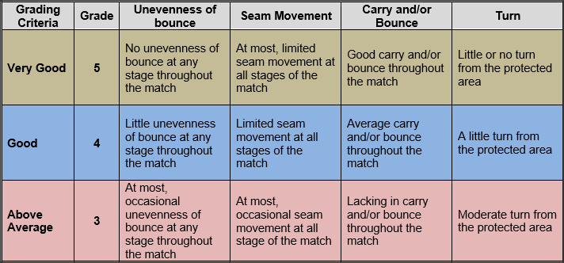

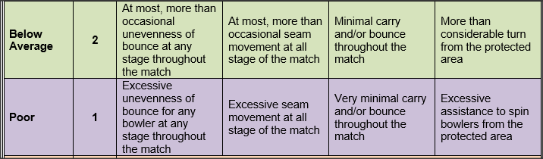

Mark how it plays not how it looks

