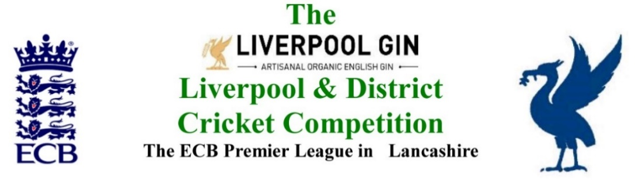
www.lpoolcomp.co.uk

M/C Meeting held at Bootle CC on Monday 26th June 2017 at 6.00pm:

6.00pm: Attendance of Newton le Willows CC

Agenda item | Recorded Minutes
1.  Apologies:  1.17pm | - All members of M/C were present being:  Eric Hadfield (President) John Williams (Chair) Chris Weston (Hon Sec); Rob Durand (1st & 2nd Team Fixture Secretary); Alan Bristow (Hon Treas); John Rotheram (Cricket Chair).
2.  Minutes: | - Signing of Previous Meetings  The Chair (JW) signed the minutes as a true and accurate record of the meeting held on 25th May 2017.  - Action Point Items  Were Considered  - Matters arising  These were to be taken en passant as they were covered by agenda items.
3. Chairman's Remarks | - Minute’s silence for London Bridge attack victims  The matter had been dealt with.  - S&D ACL/LDCC Dual Reg Draft Regulations  The matter was ongoing. The meeting with S&D ACL was scheduled for Tues 25th July.  - Pennine CL folds  LCB’s note had been circulated , aspects of this were said to be ongoing.  - MCUA: Lack of Cup umpires  EH and JW had posted on this e.g. http://www.lpoolcomp.co.uk/management_bulletins.php?id=2886 . The matter had been discussed at length by M/C who had the steered the response of the MCUA in making appointments on the day. MCUA: Posting on time allowed in Cup Games  Time could and should be added on by umpires up to 30 minutes in cup games under Cup Reg 8.3 P58.  - NCPS Games Cried Off  http://i.emlfiles4.com/cmpdoc/7/7/7/0/3/1/files/34226_ggo_liverpoolanddistrictcricketcompetition_may2017.pdf  This underpinned the GTGO ECB meeting at Old Trafford on Wed 28th June at 7-9pm. CW EH AB + Graham Kerr + Ted Williams were representing the L&DCC.  - L CCC Liverpool T20 game.  The matter was discussed, EH/RD would pursue.  - Sponsorship 2017 updates were discussed:  3.7.1 Halewood International  3.7.2 O₂  3.7.3 Scorpion  3.7.4 ICON  ICON had set up the Player of the Month Awards with JW.  3.7.5 Total Clothing Solutions  - LCB Handbook 2017 distribution  CW had full lists of how these had been distributed
4.  Club & Ground Chair’s Report | - EH 2017 inspections update  EH reported that he had “done 7”, 2 remained for processing, there were 5 left to do.  Wigan CC was discussed, JW advised that this one might need doing after their ground drainage was finished..  - Alder  Poor pitch marks had been reported by MCUA umpires.
5.  Hon Treasurer’s Report | - Figures of Account May/June  Were given  - Income and Expenditure April/May  5.1.1 All Club subscriptions 2017 had now been received, 4 on the last day and 2 using personal BACs or cheques.  5.1.2 ICON Sports had been paid for Rep Team Kit within budget. The logos were fully integrated into each other and woven into the fabric, not printed on top of each other. They looked very good and were of good quality. JW reported that they washed well too.  A club had been paid for hosting a Rep game held there, there would be other such invoices following along soon.  The L&DCC annual renewal of its insurance policy was due.  - Play-cricket Scam no panic at L&DCC  L&DCC was very much wise to this p-c based scam.  - Fines week 1 of season  These had been dealt with, http://www.lpoolcomp.co.uk/management_bulletins.php?id=2859  - Ball sponsorship 2018  The Dunkley/Readers’ sponsorship package ended in 2017. The matter was discussed.  - Pitch and Spirit Marks tranche 1  This was in hand, there had been 2 replies to the posting.
6. Registration Sec's Report | - Registrations Report RD update  To date and from Oct 2016, a total of 480 (!) players had been registered. This month this had mostly involved the registration of age group players for 3rd XIs.  - LDCC Lists of Cat 3 registration 2017 to ECB  The Cat 3 (NE) and Cat 3 (E) data had been sent to ECB by the due date and copied to M/C.  - Registration procedures in 2018  This would be discussed at a later date.
7  Fixture Sec's Report | - Rearrangements update post Cr Co:  Were discussed in detail.  7.1.3 Representative Games; “lost players” as a reason for rearranging games  M/C discussed the matter and agreed ruling that having players involved in Representative games could not be a reason for rearranging games.  - League 1st/2nd XIs  1st/2nd XI FS’ Report RD/EH  - 1st XI Ray Digman Cup  - 1st XI Ray Tyler Cup  - NatWest ECB T20  The Final on the 16th July was a problem The matter was discussed at length and two possible ways forward were agreed depending on replies yet to be received. The matter would be finalised am tomorrow.  - Rep games 2017 U12/14/18/21/All Age  JW reported that the all age Lancs inter league was progressing.  The Senior side was to play the Ribblesdale League 20/08/2017  The 3 x U21s games were organised  U18s Sun 9th July v Bolton  U12s 16th July v Lancashire League  U14s 16th July v Lancashire League  Colts 17/18 years old Tues 18th July v Vengsarkar’s (sic?) XI at Formby.  - 2nd XI Chester Cup  2nd July had lots of such games, EH had this in hand and would be posting on this. We would again probably not have enough umpires, club umpires could be used.  - 2nd XI Tittershill Cup  Seemed to be going well.  - Chrysalis Cup 2nd XI T20  Also seemed to be going well.  - Mike Leddy Cup 3rd XI 40 Over  Seemed to be going well.  - Embee Cup 3rd XI T20  No games had been played yet.  - ECB/LCB U19sT20  There was no news, CW would ask LCB about this at Old Trafford on Wed 28th.  - U16s progress  - U21s progress  These two were both rolling as agreed.
8.  Cricket Chair’s Report | - Annual Dinner 2017 update  This needed publicising again, CW would post on this.  - Cr Co 22 05 2017 Report/Matters arising to include:  The meeting was discussed.  - PoM Awards April/May  The Awards had been dealt with under 3.7.4
9. Publicity & Sponsorship Chair’s Report | - Items not previously covered under 3.7  There were none.
10. Website matters | - Gud Design for 2017  JW would ring Gud Design.
11.  Hon Secretary’s Report | - Dates of meetings  See below  The additional meetings were noted  M/C Mon 31st July was shifted to Mon 7th August  The S&D ACL meeting clashed with the ECB meeting and would need moving.  - Defibrillator Club survey  CW had circulated this. M/C was pleased that 29/40 had one, 8/40 did not and 3/40 had this in hand. JW would contact the Oliver King Foundation for the 8 clubs that needed assistance.  - NCPS survey L&DCC Questions  CW had managed to insert our 3 L&DCC specific questions.  - MCUA M/C meeting reports  - GTGO 28th June John Wright Old Trafford ECB/LCB  We were a party of 5.  - ECB “CrickFests”  This had been discussed by M/C by email. We had publicised the project.
12.  LCB / ECB Issues | - OSCAs nominations  This was progressing.  - MoU meeting NB CC 15 06 2017 meeting outcomes  This had gone well, there were no action points arising.
13.  A.O.B. | - It was asked if we had considered restricting the numbers of overs that bowlers could bowl in 2nd and 3rd teams. M/C knew that this had been discussed before and rejected by vote meetings. We played time cricket in our leagues, restricting overs was from the limited overs format.  - It was asked if we needed another 3rd XI review. A number of options were discussed.
14.  Date of Next Meetings  Meeting closed at 9.08pm | See Appendix 1  M/C Mon June 26th Bootle 1.00pm  M/C Wed 28th June Old Trafford LCB/ECB 7-9pm  Cr Co Mon July 24th Bootle 7.00 pm  Feeder League LDCC/S&D ACL Tues 25th July FWH CC 7.00pm  ECB PCLs meeting Tues 25th July Danubius Hotel Lords am  M/C Mon August 7th Bootle 1.00pm  Cr Co Mon August 14th Bootle 7.00 pm  M/C Mon August 21st Bootle 1.00pm

