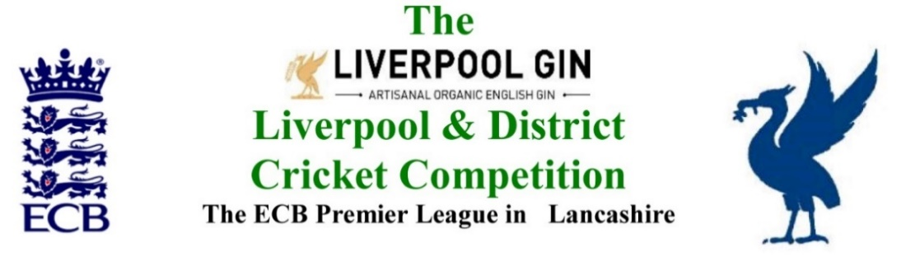
www.lpoolcomp.co.uk

M/C Minutes General Circulation 26/11/2018

M/C warmly welcomed Peter Fleetwood (Wigan CC) to the meeting, he had volunteered to take over the post of Treasurer when Alan Bristow stepped down at AGM 2019 and had been invited to the meeting to give him an insight into L&DCC’s M/C before the AGM. It was hoped he would not be too put off!

Agenda item | Recorded Minutes
1.  Apologies:  Precisely  1.00 pm | - There were no apologies.  - Present therefore were: Eric Hadfield (President); John Williams (Chair); Chris Weston (Hon Sec); Rob Durand (1st & 2nd Team Fixture Secretary); Eddie Shiff (3rd XI Co-Ordinator); Jim Hathaway (Club & Ground Chair); Alan Bristow(Treas 2018); Peter Fleetwood (Treas 2019); John Rotheram (Cricket Chair).
2.  Minutes: | - Signing of Previous Meetings  The Chair JW signed the MC minutes for the meeting 29/10/2018 as a true and accurate record of that meeting.  - Action Point Items  The Action Points were considered briefly as set out below and picked up in detail under agenda items as appropriate and necessary.  - Matters arising.  These were to be taken en passant as they were covered by agenda items.
3.  Chairman's Remarks | - SGM 06/11/18 Alder CC- outcomes;  The meeting had been a success, clubs had voted 30 to 0 in favour of the new arrangements, there had been no adverse feedback reported after the release of the minutes https://view.officeapps.live.com/op/view.aspx?src=http://www.lpoolcomp.co.uk/uploaded_files/documents/00_Minutes_2018_Management_Structure_SGM_3rd_XI_EoS_.docx either on social media or by email or by calls.  The nominations to the sub-Committees were discussed.  - Bootle and Ormskirk 2s – update  This had now been brought to a conclusion after a very difficult process.  - MYC update  JW reported that no merger with L&DCC was to take place.  MYC had their AGM on the 4th Dec that for the LC-SD-JCL was on the 18th Dec.  - Fixtures 2019, basic outlines.  This would be taken under item 7.  - Proposals to AGM 2019, decisions re Running File 2018  This discussion was to be taken on a Yes – write proposals for the M/C meeting /No further action basis, there  would be a separate M/C meeting to sort the detail  - Clubmark re- accreditations ECB/LCF Oct 2018 -update  JW noted that we were aware that two current L&DCC clubs had not re-accredited for 2019. The matter was discussed at length  - MCUA going forward  There was an MCUA meeting this coming Thursday.  JW would circulate documents to M/C and convene a meeting with MCUA after Christmas.
4.  Club & Ground Chair’s Report | - JH Report  There was nothing adverse to report.  M/C felt that the job had been well done and thanked JH and asked him to produce 2 or 3 of his excellent .xls graphics as .ppt slides for the AGM as part of a brief presentation to that meeting.  - Norley Hall CC, CW visit 21 11 18  M/C had met three Norley Hall CC officials at their club last week. The visit had gone well, the club was very pleased to have just gained Clubmark accreditation.  The six-bullet points: Sight-screens/Scoreboard /Umpires room/Players Viewing Area/Practice Facilities /Ladies Room from the C&G e-mail were all in hand to varying degrees.  - SoC Marks, adjustments thereto.  M/C discussed the issue of L&DCC disciplinary adjustments to the umpire’s SoC marks in 2018.  The three divisional winners in 2018 were as follows;  Prem: Colwyn Bay,  Div 1: Prestatyn,  Div 2: Northop Hall.  As these were all our Welsh clubs M/C felt there was a journalistic opportunity here!
5.  Hon Treasurer’s Report | - Auditing of accounts for AGM 2019  - AB received the audited accounts in real time during this meeting, he would send M/C the audited accounts as soon as he could after checking them.  - AB would write a report for the AGM 2019 papers as soon as possible.  - AB had written a four-page hand-over pack for Peter F together with a USB memory stick with the accounting package used by the L&DCC.  - We needed to make a transfer of bank mandate.  - Figures of Account Oct/Nov 2018  As of 26/11/2018 were given.  - Income Oct/Nov 2018  We had received monies from the Liverpool Echo to cover the costs of the 2018 Final.  - Expenditure Oct/Nov 2018  All bills were paid to date with the exception of the cost of the auditors i.e. Messrs JVSA. This figure was TBC.  - Main sponsor: Liverpool Gin  JW noted that LG wanted to take The President and the Chair out for a meal as part of the now confirmed third year of LG sponsorship for 2019.  LG were now sponsoring Rangers FC.  - Outline Budget 2019  AB would write this for Peter F as a basic framework on which he could build.
6.  Registration Sec's Report | - Registrations Report RD update  - RD reported that Norley Hall CC had added players and deleted others.  - There were a few other registrations pending, again these were in hand.  - RD raised the case of an ex-L&DCC player Adnan Ghaus (an ex New Brighton CC player ) who had been playing for Elworth CC in the North Staffs and South Cheshire PCL https://www.stokesentinel.co.uk/sport/other-sport/elworth-hit-massive-points-deduction-1934500 and who had been caught in the ECB/Home Office Managed Migration checks. They had been deducted 270 points.  Adnan Ghaus had been incorrectly registered, He had been playing as a 48-month residence qualified ECB Cat 1 (a Cat 1b in L&DCC systems). Upon close inspection it was shown that he had lost this status having been out of the UK for more than the allowed number of days per annum asset out in ECB residence qualifications i.e. the 35/70/210 days totals.
7.  Fixture Sec's Report | - 1st/2nd XI FS’ Report RD  7.1.1 Norley Hall CC meeting – taken under 4.2  7.1.2 EH had put a note on the website http://www.lpoolcomp.co.uk/management_bulletins.php?id=3215 about special consideration for clubs when writing the fixtures. CW had circulated it. There had been several responses already.  7.1.3 The County Cricket Club fixtures were due for release tomorrow Tuesday 29th Nov 2018  - 3rd XIs League Coordinators Report  Formats for 2019 were discussed post the 3rd XI survey and the meeting 06/11/18. Various scenarios were suggested and considered in detail.  Saturday would be Prem (12) + Div 1 (17), no single midseason breaks.  Saturday 27th April 2019 to Saturday 31st August 2019  Sunday would be Prem (10) Div 1 North (9) Div 2 South (9) again no single mid-season break  Sunday April 21st to Sept 22nd  EH would work with ES and collate and circulate draft fixtures based on these decisions.  - 1st XI Ray Digman Cup  - 1st XI Ray Tyler Shield / Cup  - 1st XI ECB T20  - 2nd XI Chester Cup  - 2nd XI Tittershill Shield/Cup  - Chrysalis Cup 2nd XI T20  - Mike Leddy Cup 3rd XI T40  - Embee Cup 3rd XI T20  Cup Entries EH would post on these for 2019 making clear those which were based on club choice and which needed to done asap and those which were mandatory entries. CW would e-circ the posting.  - MCC Game 06/08/2019  - Rep games 2018 U12/14/18/21/All Age  - ECB/LCB U19s T20 2019  - Brighton/Sussex touring side  - Echo Cup – review of rules 2019  - LC-SD- JL MYC  - ES reported that New Brighton CC had been allocated a Minor Counties match Cheshire v Lincolnshire 16/06/19. CW added that NB CC were also hosting the 2019 MCC v L&DCC match 06/08/19.
8.  Cricket Chair’s Report | - Cr Co outcomes  No Cr Co meeting had taken place 19/11/2018 in view of the meeting 06/11/18.
9.  Publicity & Sponsorship Chair’s Report | - ICON: an article was to follow, they had revolutionary ideas for protecting cricketers. https://iconsports.co.uk/cricket-shop/icon-arm-r-s-iconarms
10. Website matters | There was no report
11.  Hon Secretary’s Report | - Dates of meetings going forward  M/C approved the base outline of provisional dates for meetings in 2019 See Appendices 5 and 6 as circulated by CW and hard copied to this meeting.  - 15/11/18 EOT MoU 2018 review MoU 2019  CW ran through briefly the L&DCC/LCF review of MoU 2018 and that planned for 2019, again as previously circulated.
12.  LCF/LCB | - Pre- Season MoU meeting with L&DCC  This was in the diary for Tues 12th Feb, LCF was keen to “come to us” in 2019.  - ECB 2019: CW had spoken to both Tessa Whieldon and Paul Bedford, ECB was still planning for 2019 and the financial relationships with Sport England were central here.  - LCF proposals: JW would circulate papers on his dealings with LCF and their dealings with the “Big Leagues” in Lancashire.
13.  A.O.B. | - A discussion on the nomination of Vice Presidents for presentation to AGM 2019 took place.
14.  Date of Next Meetings  16.20pm | Dates of Meetings Summary  M/C Dec 6th New Brighton 1.00 pm  L&DCC AGM Tues 15th Jan 2019 Bootle 7.30pm

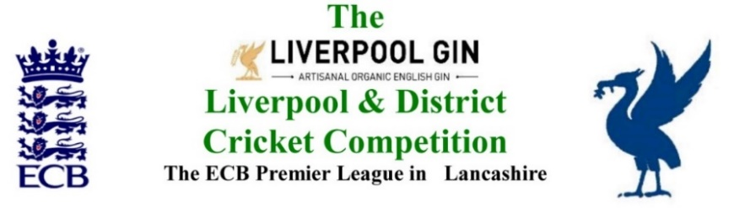
www.lpoolcomp.co.uk

The next meeting will be held at Bootle CC on Monday 28th January 2019 at 1.00 pm. at Firwood-Bootle CC.

DRAFT

Agenda to include

- Apologies

- Minutes
Action Points
Matters Arising

- Chairman's Remarks

- Hon Treasurer’s Report

- Hon Secretary’s Report

- Registration Sec's Report

- Fixture Sec's Report First and Second XIs

- Club and ground sub-committee

- Cup competitions sub-committee

- Disciplinary sub-committee

- Junior league sub-committee

- Third X1s sub-committee

- Women’s and girls’ sub-committee

- LCB / ECB Issues

- A.O.B.

- Date of Next Meetings

