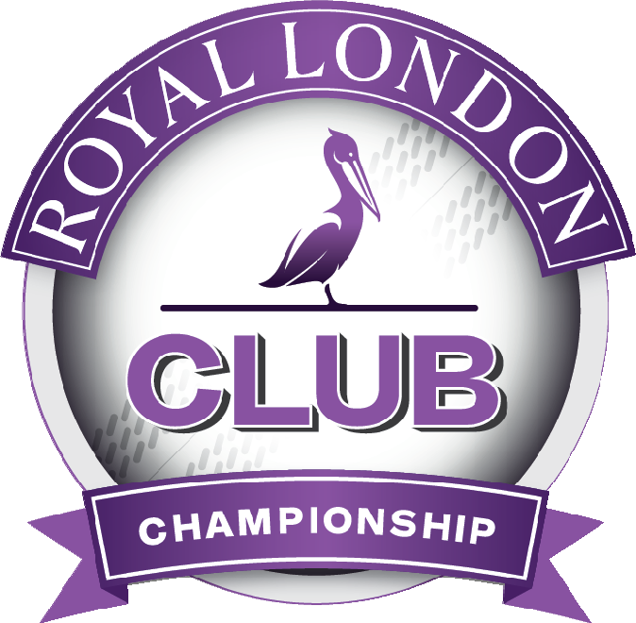
Dear Club Secretary 14 October 2015
Royal London Club Championship 2016

We would like to invite you to enter the 2016 Royal London Club Championship (the ECB National Club Championship), dates of which I am pleased to provide below.

The entry for next season’s competition will remain at £50 if paying by BACS and will be £55 if paying by cheque. Details of how to do this are on the entry form itself which you will find attached which is to be completed and returned no later than Friday 4 December 2015. Any entries received after this date may only be considered if the draw is not already full.

We are once again limited by the busy summer schedule to a competition of just 8 rounds; therefore only 256 clubs can enter. All participating clubs from the 2015 competition have been invited and demand traditionally exceeds supply so it will be necessary to limit the number of clubs that are included. The following criteria will be used in judging suitable entries (please note the requirement to be ECB Clubmark accredited has been removed for the 2016 season):

- The League and Division that the Club plays in on a Saturday
- Standard of the Club’s ground and ancillary facilities
- Previous history of the Club in the competition.

As such this invitation and your completion of the entry form is not a guarantee that your club will be included in the competition for 2016 as the above entry criteria may need to be invoked.

The draw for each Group will be released by January 2016 at the latest and seeded based on the record of the club in the previous season both in this competition and in the ECB Premier Leagues.

The First Round is to be played by Saturday 30 April 2016 at the latest although fixtures will be scheduled for Sunday 24 April 2016. Clubs involved in 10 team leagues, i.e. those starting later on in the season, are encouraged to play these matches as early as possible and one option is for clubs to utilise the Saturday prior to the start of their League season for these First Round matches or any team may agree to play their first round match on any Sunday in April if they wish.

ECB will cover the costs of the umpires for all rounds of the competition (they will claim direct from ECB). Each host club will receive match balls for all home matches throughout the competition, please indicate on the entry form whether you would prefer to have these balls sent to your club or contact person’s home address.

The National Final will be held at a first class ground to be confirmed once the First Class Fixture List is published in December 2015 by the ECB First Class Cricket Department.

Yours sincerely,

Aaron Campbell
Competitions Executive
Provisional Dates for 2016
Round First Second Third  Fourth (Group Final) Fifth  Quarter final Semi final Final | Scheduled Date  24 April 2016 (played by 30 April)  8 May 2016  29 May 2016  19 June 2016  10 July 2016  31 July 2016  28 August 2016  18 September 2016 | Wet Weather Reserve Date  2 May 2016 (can be earlier if agreed)  15 May 2016  5 June 2016  26 June 2016  17 July 2016  7 or 14 August 2016 (depending on T20 matches)  4 September 2016  25 September 2016

