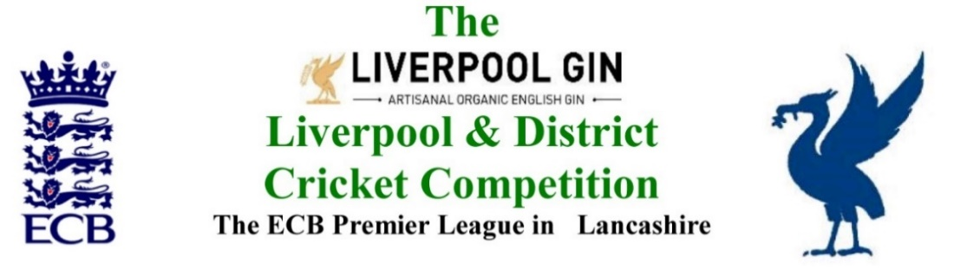
www.lpoolcomp.co.uk

M/C Meeting held at Bootle CC on Monday 24th September 2018 at 4.00 pm:

Appearance of Northern CC re Digman semi (3) 09/09/2018

Agenda item | Recorded Minutes
1.  Apologies:  3.58 pm | - Jim Hathaway (Club and Ground Chair) gave his apologies, he had sent a detailed report  Present were: Eric Hadfield (President); John Williams (Chair); Chris Weston (Hon Sec); Rob Durand (1st & 2nd Team Fixture Secretary); Eddie Shiff (3rd XI Co-Ordinator); Alan Bristow (Hon Treasurer);
2.  Minutes: | - Signing of Previous Meetings  The Chair JW signed the two sets of minutes Tuesday 28th August 2018 and Tuesday 4th September 2018 of M/C minutes as true and accurate record of the meeting.  - Action Point Items  The Action Points were considered briefly as set out below and picked up in detail under agenda items as appropriate and necessary.  - Matters arising.  These were to be taken en passant as they were covered by agenda items.
3. Chairman's Remarks | - L&DCC Presentation afternoon 07/10/2018 see Appendix 1 PoM and PoY/Trophies/Running Order  This item was taken first was taken first.  http://www.lpoolcomp.co.uk/management_bulletins.php?id=3184  JW informed that only one club (SP CC) had replied to this posting and e-circ of it.  How many clubs actually needed to reply was posed. CW advised that the L&DCC Constitutional quorum was 12 full member clubs i.e. one third of all full member clubs. This was agreed.  In the meantime, CW would ring Firwood-Bootle CC and “put them on stand-by notice” that a cancellation of 07/10/18 was probable.  - Northern and Bootle semi-final of Digman 09/09/18  M/C would discuss this at 6.00pm.  - 2nd XIs Div 1 points deductions Sept 2018  The many matches that this applied to had been dealt with already, it had taken up a lot of time for a lot of M/C and had been talked about already. Effectively it referred to TBA matches in 2019.  M/C warned that “no TBAs” would have an impact on the fixtures for 2019, the fixtures would need to be done soon and certainly before Christmas.  - CW ECB meeting Paul Bedford 16/09/1  CW ran through his conversations with Paul Bedford.  - Northern and Bootle 2s update  This was a matter for the Disciplinary sub-Committee, it was very complex and time consuming.  Tim Kenward had given very good legal advice, L&DCC had followed this.  - MCUA and appts meeting  No meeting in Sept had been set up yet.  - Women’s and Girls Cricket Paul Bate attendance at M/C  JW was to meet Paul B on the 26th (Wed ?) to look at his report. He had achieved a lot. He would also be coming to our next M/C meeting on the 29th Oct.  - Parkfield Liscard in attendance at M/C  Parkfield Liscard CC would be coming to our next M/C meeting on the 29th Oct.  - End of season meetings MYC JL update  No action here was needed, the meeting with officials this week was TBA this week.  - Feeder League meeting 13/09/18 report  This had taken place and been very successful.
4.  Club & Ground Chair’s Report | - JH Report  The JH End of Season reports on Pitch and Spirit Marks needed for the ECB as part of premier league accreditation 2018 had been received.  M/C was impressed, this was a very good very detailed piece of work.  CW/AB would discuss this out-with the meeting, CW would abstract an executive summary of six tables x3 SoC and x3 Pitch Marks, i.e. one of each for each of the three divisions and send both the summary and the full report minus the information tables that could allow identification of individual umpires, to the ECB in the usual formal way.  - Norley Hall report update EH letter  EH had already sent this.
5.  Hon Treasurer’s Report | - Figures of Account Sept  Were given as at 14.30 24/ 09 / 2018  - Income Sept 2018:  - Fines  We expected the fines to total circa £8k.  - Readers Ball sponsorship 2018  We had received sponsorship from Messrs. Readers. This figure included that for Sovereign balls.  AB had subtracted the cost of balls for L&DCC Representative Games, the rest would be returned to the clubs that had purchased Reader balls as discount. This discount was substantial being more than 10% for each Special County Imperial Crown ball, exact figures were given.  - Expenditure Sept 2018:  - All invoices were paid  - Expenditure of about £20k to the clubs etc. was calculated and anticipated, much the same as last year. This would leave about £45k in total funds which again was much the same as last year.  The meeting congratulated AB on his fine stewardship of the L&DCC funds  - Budget 2018 update  There was no report as such, but AB would prepare a statement to be read out at the End of Season meeting.  - Cost of Teas and umpires for Echo Cup 2018  JW would ring Tom Evans over this.  - AB Paper re Cost to L&DCC of Rep games going forward  AB preferred now to leave this to the discretion of the 2019 L&DCC M/C as he would not be in post by then. This was agreed.  - Booking PDP St Bede’s and Indoor League Final St Margaret’s  JW had provisionally booked both PDP and Indoor League Final at St Bede’s.  - Hon Treasurer 2019  AB would pay the clubs their 2018 moneys by BACS, get the accounts up to date and have them audited. He had already referred to AGM 2019.  AB would start a new set of accounts for 2018/2019 and keep going until his successor was appointed.  No successor as Hon Treas of the L&DCC was known. We needed to advertise. A posting should be made.  JW intended to suggest a new committee structure for the L&DCC under AOB at this meeting.
6.  Registration Sec's Report | - Registrations Report RD update  6.1.1 RD reported that there was nothing was coming through at the moment. JW noted lots of activity on Twitter alleging player movements.  6.1.2 RD would be removing Cat 3 (Not Exempts) from play cricket next week, their registration status having lapsed under our regulations.  6.1.3 Players flagged as “3rd XI ONLY” having been registered post 31/07/2018 would have their “ONLY” flags removed going forward.  6.1.4 RD would remove the Norley Hall CC Dual Registered players from other L&DCC clubs now that they were full a member club in 2019.  - Dual Registrations going forward  This new-for-season 2018 really had “ worked” with our Feeder League.  L&DCC had registered 53 of them for use in the Feeder League, the S&D ACL 23 for use by the L&DCC. It was a good news story. More players were getting games. CW would write to ECB/LCF.
7.  Fixture Sec's Report | - Fixtures 2019  - 1st/2nd XI FS’ Report RD  Formby 2s v Northern 2s  This had not been played and was now recorded as “match abandoned” 5 points each.  - TBA Rearrangements going forward to 2019  This had been taken under 3.3.  - 3rd XIs League Coordinators Report  CW Liverpool 3s v SP 4s 25 08 18  CW had this in hand, he was to meet Charles Daniels tomorrow if there was no additional M/C meeting needed then.  - 1st XI Ray Digman Cup  - 1st XI Ray Tyler Shield / Cup  - NatWest ECB T20  - 2nd XI Chester Cup  - 2nd XI Tittershill Shield/Cup  - Chrysalis Cup 2nd XI T20  - Mike Leddy Cup 3rd XI T40  - Embee Cup 3rd XI T20  This had gone well, thanks were given to RD for presenting as were big thanks to NleW for hosting this really well.  - MCC Game 07/08/2018  - Rep games 2018 U12/14/18/21/All Age  - ECB/LCB U19sT20 2018  - Brighton/Sussex touring side 2018  - Echo Cup  - LC-SD- JL  - Stephen Croft Testimonial Game 2018
8.  Cricket Chair’s Report | - Cr Co outcomes  There was no report. A new structure for L&DCC meetings might help going forward.
9.  Publicity & Sponsorship Chair’s Report | - Tom Evans 2019  Tom had had a very good year his work for us in the Liverpool Echo had been excellent. CW had formally thanked him on our behalf.  - PoM ICON presentations  JW would ring Will Purser and discuss what we were doing going forward.  - LG Sponsorship 2019  The matter was ongoing.
10. Website matters | There was no report
11.  Hon Secretary’s Report | - Dates of meetings going forward  A discussion on this was deferred as time was short.  - Trophies  ES now had possession of all of these and would be handing them over to JR for engraving.  CW gave JR a hard copy list of the winners and runners up for both juniors and seniors as far as they were known  S&B CC had asked to borrow the 1st XI 1st Division Trophy for their dinner on the 29th Sept.  - SV CC 2nd XI Captain sentencing report Wigan Press  CW noted that the 2nd XI captain from Spring view had been sentenced, this was now in the press.  https://www.wigantoday.net/news/crime/sports-coach-from-wigan-sent-sordid-messages-to-teens-1-9338407
12.  LCF/LCB | - End of Season MoU meeting with L&DCC  Was noted as 25/11/18
13.  A.O.B. | - Pitch and Spirit Marks  AB produced hard copy of the 2017 adjustments for the 2017 SoC marks.  - JW proposed new committee structure in the L&DCC  JW produced hard copies.  JW went through this in detail. He thought that the existing structure was not working and needed changing. The handbook would also need changing to reflect this new structure, there would need to be a proposal to AGM 2019, but JW would also outline this at the End of Season meetings.
14.  Date of Next Meetings  5.57pm | Dates of Meetings Summary  M/C: Monday October the 29th 2018 at Bootle CC ? at 4.00pm?  M/C Mon 24th Sept Alder 4.00pm  Presentation Afternoon Sun 7th Oct Bootle 12.00 noon  End of Season Tues 16th Oct Sefton Park 7.30pm  M/C Mon Oct 29th Bootle CC ? 4.00pm?

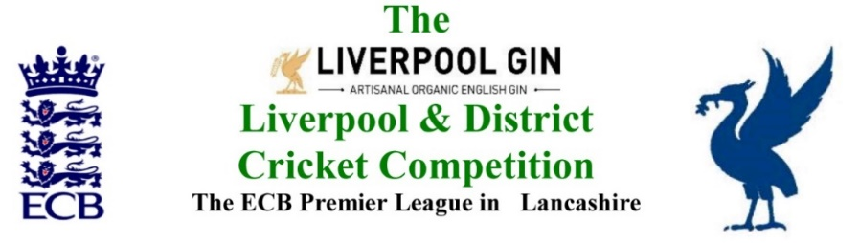
www.lpoolcomp.co.uk

The next meeting will be held at Bootle CC on Monday 29th October 2018 at 4.00 pm.

DRAFT

Agenda to include

- Apologies

- Minutes

- Chairman's Remarks

- Women’s and Girls Cricket

- Club & Ground Chair’s Report

- Hon Treasurer’s Report

- Registration Sec's Report

- Fixture Sec's Report

- Cricket Chair’s Report

- Publicity & Sponsorship Chair’s Report

- Website matters

- Hon Secretary’s Report

- LCB / ECB Issues

- A.O.B.

- Date of Next Meetings

