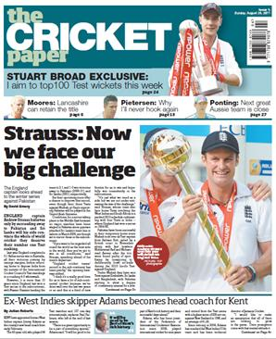

Press Release:

An exciting new addition to the world of cricket is set to be launched on May 16, 2012.

The Cricket Paper, a weekly publication packed with news, reports and features about the sport, will be launched by the same stable that brings readers the highly-regarded Sunday newspapers The Rugby Paper, The Non-League Paper and The Football League Paper and the football fans’ magazine, Late Tackle.

The Cricket Paper, a national newspaper in England and Wales, will be the UK’s only all cricketing newspaper covering cricket matches from around the world, from elite level to local domestic cricket. Chief correspondent will be Peter Hayter, the award-winning writer with The Mail on Sunday.

One of the unique aspects of The Cricket Paper’s 40 page coverage of the cricket scene is its depth - with more than 60 match reports, round-ups from all 25 ECB county leagues and comprehensive results service.

Targeted at the millions of fans and spectators who enjoy the game, and specifically for the estimated 1.2million active participants in the game and their 15,000 cricket clubs in the UK, The Cricket Paper, at £1.50, will be available every Wednesday in newsagents and supermarkets.

David Emery, MD of Greenways Publishing, and the publisher of The Cricket Paper, commented, “Like our other publications, specifically, The Rugby Paper and The Non-League Paper, we will offer unrivalled coverage of the game from the grass-roots up to professional cricket, and we think that appeals to a lot of passionate and dedicated players and fans of the sport. I’m delighted to be launching The Cricket Paper.

##Ends##.

Notes to Editors:

Greenways Publishing are a leading weekly sports newspaper media company publishing The Rugby Paper, Non-League Paper, The Football League Paper and Late Tackle magazine.

Contact:

Greenways Publishing:

- David Emery, Managing Director email: david.emery@greenwayspublishing.com
- Sam Emery, Head of Advertising email: sam.emery@greenwayspublishing.com
- Neil Wooding, Trade Marketing Manager email: neil.wooding@greenwayspublishing.com

- Telephone 0208 971 4333
- Website: www.thecricketpaper.com. Follow The Cricket Paper on Twitter @TheCricketPaper
- Address: The Cricket Paper, Tuition House, St George’s Road, Wimbledon, SW19 4EU.

