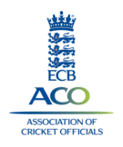
ECB
Association of Cricket Officials
(Merseyside Branch)

***** LOCAL CRICKET NEEDS YOU *****
Have you considered becoming a properly trained, qualified umpire?
Do you wish to join an organisation who will ensure your future in local cricket
by being trained to attain an ECB recognised qualification?

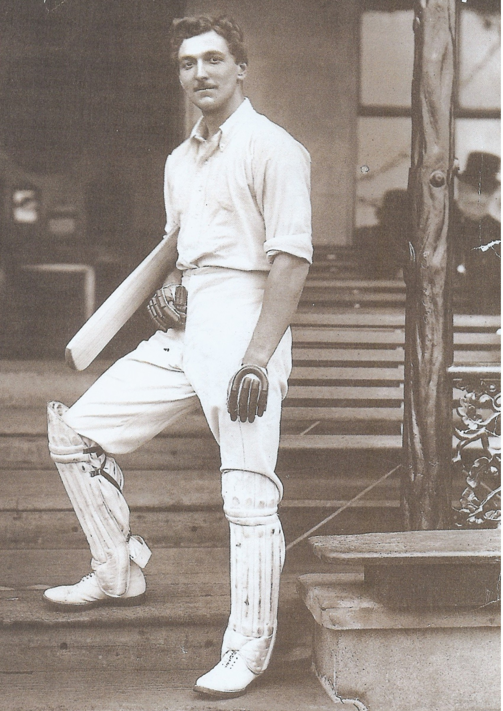

Why not enrol this winter in a training course?

The course lasts for 10 weeks, 7:30 to 9:30pm.
It starts on Monday 6th October and takes place at Bootle CC, Wadham Road, Bootle
using modern audio-visual training aids.

(Level 1 COURSE - fee £10.00)

For more information contact the training officer:

or Kevin Wilson at kevin1949@btinternet.com
or 0151 510 9241

or Mike Leddy at mikel.15@hotmail.co.uk
or 0151 445 9970

to ensure your place on the course
or alternatively just turn up on the first night.

As umpires we all owe it to cricket, the clubs and the players to be properly trained in the laws of the game to the highest standards possible and, as we know only too well, the real shortage of umpires in our own local leagues.

Thanks,umps!
Great decision.
You certainly know the lbw law after all those training sessions you’ve been on.
WELL DONE!

STARTS MONDAY
6th OCTOBER 2008 at :
BOOTLE CC
WADHAM ROAD
BOOTLE
L20 DD
FOR 10 WEEKS

