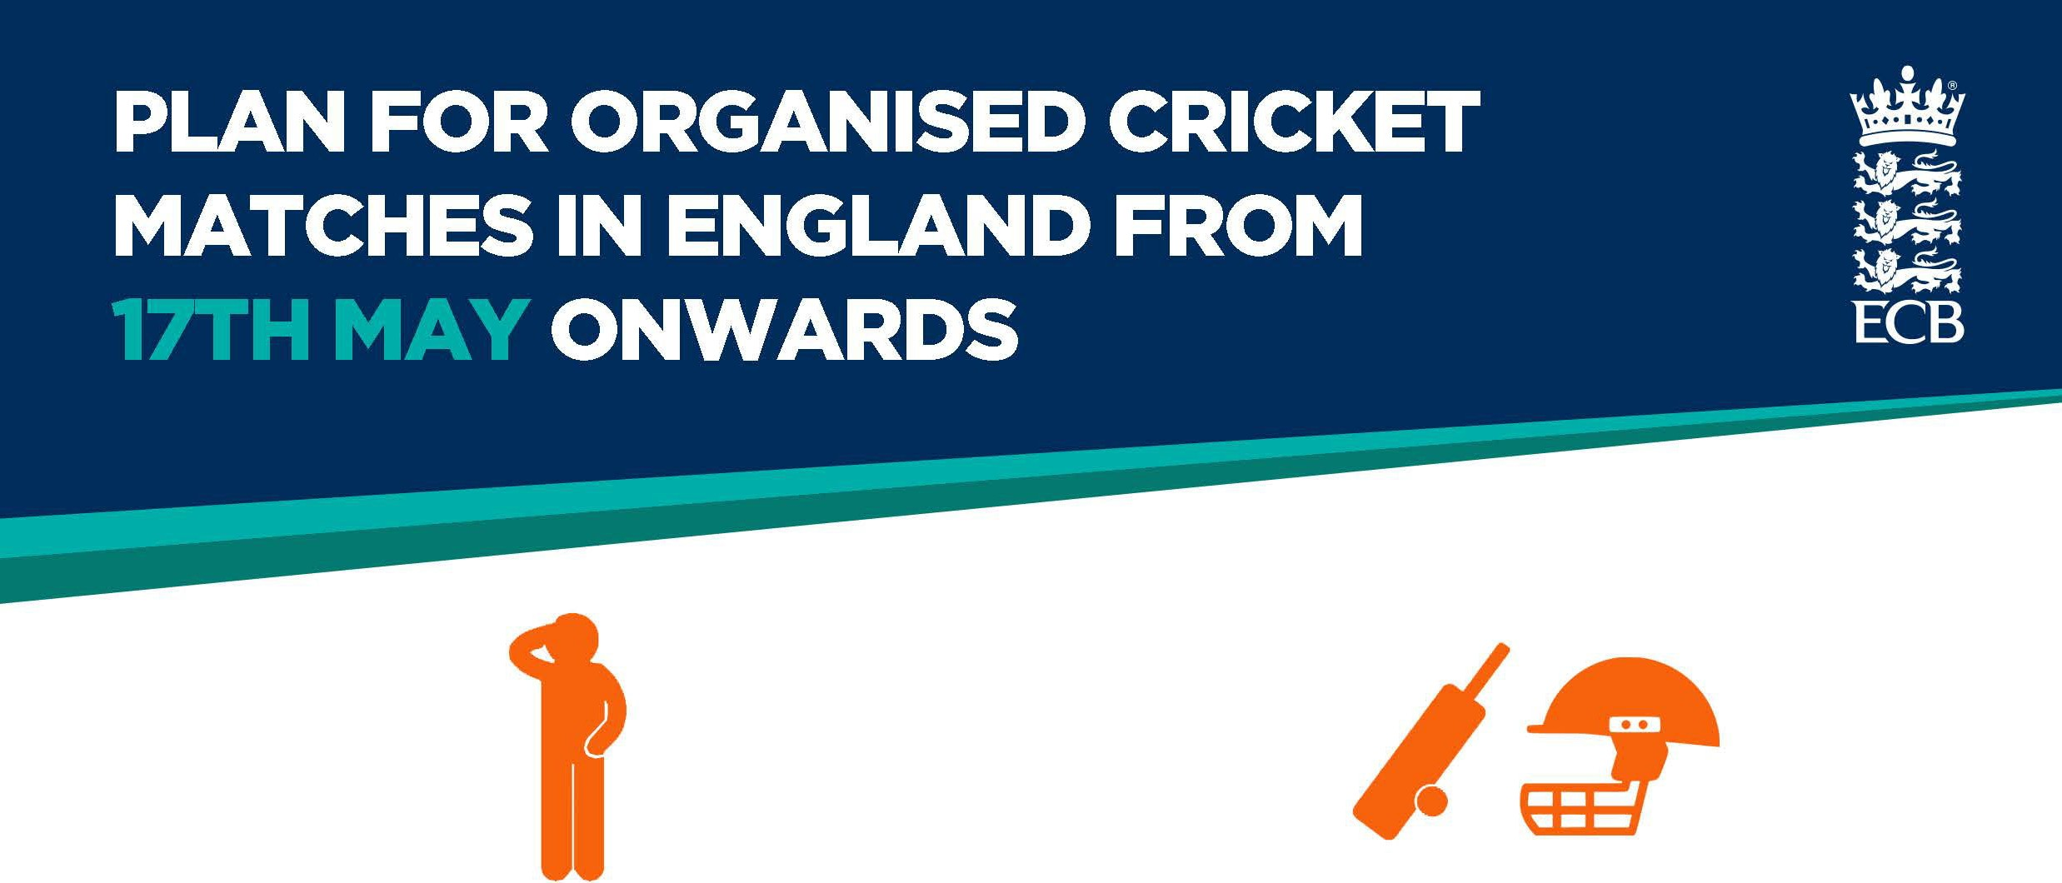

As restrictions on social distancing, group sizes and compulsory mask wearing ease from 19th July, we can still help to keep one another safe during the COVID pandemic by taking the following measures.

No participants = No game
Minimise close contacts on and off the field to reduce the risk of the virus transmission and the impact of self-isolation on your club.

Fresh air reduces risk of transmission Ventilate your indoor spaces - open windows
and doors and use suitable mechanical ventilation where available.

Keep outdoors where possible.

Display your NHS Test and Trace QR code Poster
You are no longer required to collect and maintain visitor contact data for NHS Test and Trace but you should continue to display an NHS Test and Trace QR code poster for those who wish to check in with the NHS
COVID app.
Good hygiene kills the virus
Keep cleaning spaces, surfaces and touch points frequently.

Make hand santiser available throughout your venue and consider keeping hygiene breaks in play.

Review where you want to advise mask use Consider advising the use of face coverings in crowded or poorly ventilated indoor spaces.

Risk assess staff who are working in indoor spaces or are meeting lots of customers.

The use of face coverings in service of food and beverage can help to build customer confidence.

Maintain your COVID risk assessment Your COVID risk assessment remains a
valuable tool for assessing and addressing the COVID risks that still remain, and it could be necessary under your H&S obligations as an employer. Keep it under review as guidance changes.

For more information please visit ecb.co.uk/covid-19

