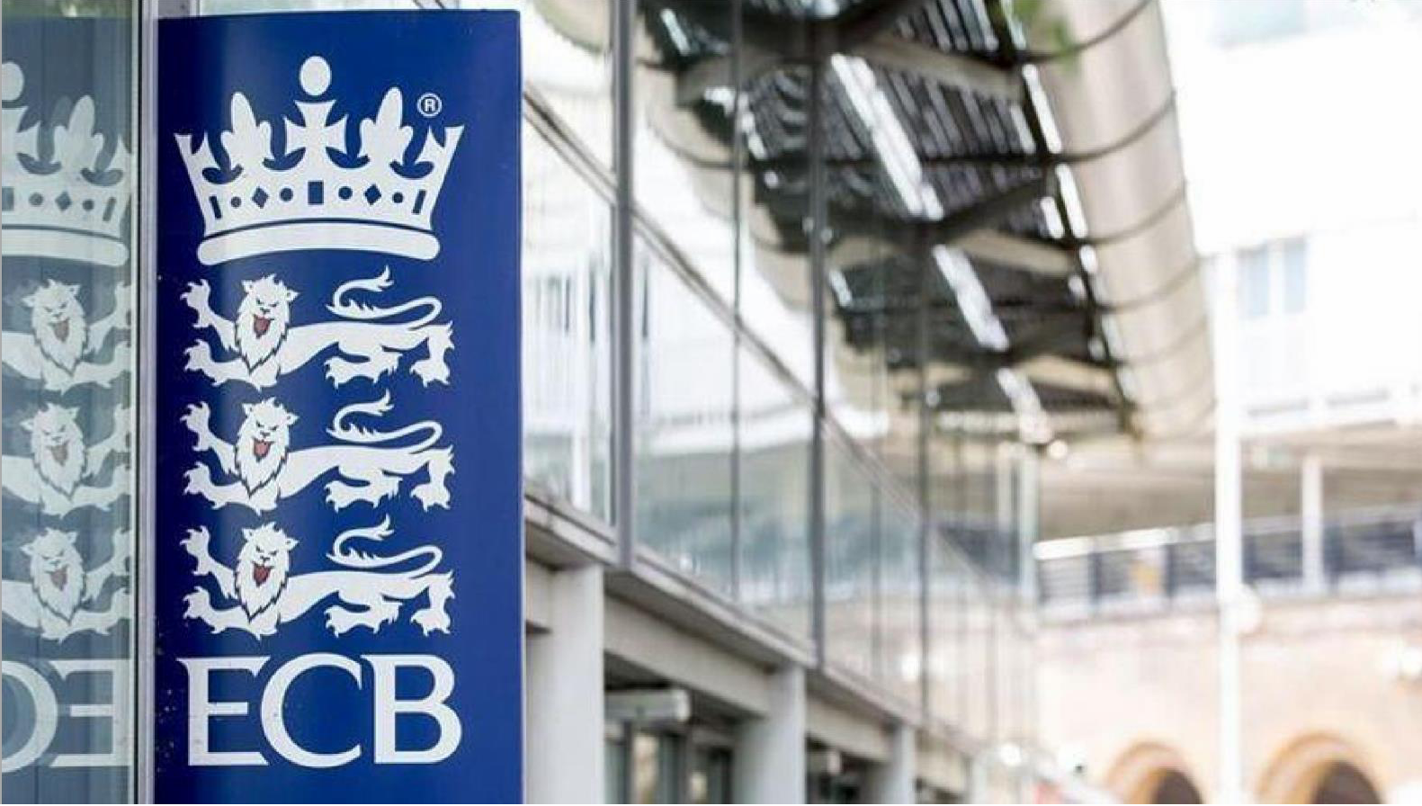

SUGGESTED SPECIAL MEASURES FOR CLUBS AND COMMUNITY TEAMS FOR NON-COMPLIANCE OF COVID-19 UK GOVERNMENT AND/OR ECB GUIDANCE

PURPOSE OF THE PAPER

To provide County Cricket Boards (CCBs) Leagues and Competition Organisers with suggestions of action they can take against clubs who fail to comply with government and/or ECB guidance on the return to recreational sport and cricket.

SUMMARY OF THE ISSUE

The ECB worked collaboratively with Sport England and the Department of Digital, Culture, Media and Sport (DCMS) to put in place guidance to try to ensure the safety of those involved in the return to recreational cricket.

During the pandemic, the ECB has been working to three principles

- Public and Workforce Safety
- Support the Cricket Network
- Working in Partnership

Since returning to cricket under Step 4 of ECB Guidance the vast majority of clubs and teams appear to have been operating within the guidance. While not all clubs had everything on the field in place in Week 1 (11 July) many adjusted their operations having learned good practice from CCBs, Leagues and opposition. It is deemed essential to continue the drive of adherence to the guidance. To achieve observance of the guidance, CCBs, Leagues and Competition Organisers can assist to ensure that a minority of clubs do not bring a cessation of cricket for others.

It is evident that a few clubs and teams have pushed, and in some cases, overstepped the boundary. The result is that those operating outside of essential parts of the guidance need to be brought back into ‘safe operation’ quickly.

Recommendation

Breaches of UK Government Guidance and/or ECB Step 4 Return to Cricket Guidance listed on the COVID-19 Plan for Junior and Open Age Cricket, see below, will result in the following action:

- A first and final warning to be issued to club and/or community team to ‘cease and desist’ any operations that are outside of guidance within 48hrs of the notification of breach.
- The advice contained within the communication to the club and/or team is to be that, fast-acting ‘Special Measures’ will be implemented with immediate effect following a second breach of Guidance.

Special measures will allow:

- CCBs to decide upon the type of support, see below, that will potentially be lost by the club or team not immediately addressing the reported issue/s.
- Leagues, affiliated to CCBs, or to the National Cricket Conference via National Asian Cricket Council, to use powers invested in them by member clubs to deliver fair and proportionate sanctions club or community team not immediately addressing the reported issue/s.

Specific Areas of Breach

All breaches listed on the COVID-19 Plan for Junior and Open Age Cricket and other specific breaches such as spectators throwing the ball back into play, players breaking quarantine rules and other UK Government Guidance not explicitly listed on the COVID- 19 plan should also be acted upon by issuing a first and final warning letter and if a second breach will result in action.

Reporting

In these extreme times it is reasonable to expect that a CCB, League or Competition Organiser will accept a report from anyone involved in cricket and from a member of the public.

Recording

It is expected that a CCB, League or Competition Organiser will keep a record of date, time, event and action taken.

MEASURES FOR CONSIDERATION, IN COLLABORATION WITH COUNTY CRICKET BOARDS, FOLLOWING A SECOND BREACH

For Leagues & Competition Organisers:

Fair and proportionate use of their existing powers might include:

- Immediate suspension from all fixtures for individual teams or whole club
- Immediate suspension from ‘Home’ fixtures for individual teams or whole club
- Player suspensions
- Club fines
- Points deductions from the current competition season

For County Boards

- Support to achieve Clubmark Accreditation
- Support for Club Development Planning
- Advocacy for club Coaches & Officials for access to courses
- Access to tickets, merchandise, guard of honour opportunities from the First- Class County (or neighbouring county)
- Entry into future County based Junior Competitions
- Entry in future County based Open Age Competitions

The recommended method of delivering these sanctions is that the club, even if part of a multi-sport facility, agrees to a self-imposed sanction which is accepted by the County Cricket Board or League. In the event of a club not taking responsibility and not voluntarily agreeing to a penalty/sanction the County Cricket Board, League or Competition Organiser is expected to provide a fair and proportionate sanction without a tariff discount normally reserved for clubs taking immediate action.

