LL L&DCC End of Season Meetings 2022

Tuesday 7th November 2022 7.00pm at Firwood-Bootle CC 7.00pm

Agenda

1. Welcome.
1.2 Apologies.
1.3 Roll call of member clubs.
2. Chairman’s opening remarks
2.1 EDI
3. Season 2022
Notification of the Player of the Season 2022 Awards.
3.1. Cups Leagues and Cups Results 2022
4. Season 2023
4.1. 1st and 2nd XIs Leagues and Cups 2023
4.2. 3rd XIs Leagues and Cups 2023
4.3. Overseas players
5. Financial Update
6. Club and Ground
6.1. 1st XI MCUA Behaviour Marks
6.2. 1st XI MCUA Pitch Marks
7. Safeguarding
8. MCUA
9. Women's and Girls
10. Junior Leagues
11. Any other business.
12. Notices
Close of meeting

1. Welcome.

John Williams (JW), the L&DCC Chair, welcomed representatives to their meeting at 7:02 pm, he was pleased to see everyone and thanked them for coming.

1.2 Apologies.

Chris Weston (CW), the L&DCC Secretary, had received apologies from:

- Charlie O’Mahony, the L&DCC President,
- Eric Hadfield, the former L&DCC President,
- Liz Sinker, the L&DCC Women's & Girls Chair.

CW noted that it was not possible for clubs to give apologies for non-attendance at meetings such as this as, constitutionally, it was mandatory for all clubs to be represented at meetings such as this but personal apologies were fine.

1.3 Roll call of member clubs.

 | FULL MEMBER  CRICKET CLUB: | Present  / absent | ASSOCIATE MEMBER  CRICKET CLUB: | Present  / absent
1 | AINSDALE |  | (BIRCHFIELD PARK 3rd XIs) | N/A
2 | ALDER |  | BURSCOUGH JLs | N/A
3 | BIRKENHEAD PARK |  | GOODLASS 3rd XIs
4 | BOOTLE |  | LIVERPOOL SUPERKINGS 3rd XIs
5 | CALDY |  | MAWDESLEY JLs | N/A
6 | COLWYN BAY |  | MERSEYSIDE COMMONWEALTH 3rd XIs
7 | FLEETWOOD HESKETH |  | MERSEYSIDE SPORTS AND CULTURAL 3rd XIs
8 | FORMBY |  | OXTON 3rd XIs
9 | HIGHFIELD |  | SKELMERSDALE JLs | N/A
10 | HIGHTOWN ST MARYS |  | SOUTH LIVERPOOL 3rd XIs
11 | LEIGH |  | TARLETON W&Gs | N/A
12 | LIVERPOOL |  | UPTON W&Gs | N/A
13 | LYTHAM |  | WHITEFIELD 3rd XIs
14 | MAGHULL |  | WIDNES JLs | N/A
15 | NEW BRIGHTON
16 | NEWTON le WILLOWS
17 | NORLEY HALL
18 | NORTHERN
19 | NORTHOP HALL
20 | OLD XAVERIANS
21 | ORMSKIRK
22 | ORRELL RED TRIANGLE
23 | PARKFIELD LISCARD
24 | PRESTATYN
25 | RAINFORD
26 | RAINHILL
27 | ST. HELENS TOWN
28 | SEFTON PARK
29 | SOUTHPORT AND BIRKDALE
30 | SOUTHPORT TRINITY
31 | SPRING VIEW
32 | SUTTON
33 | WALLASEY
34 | WAVERTREE
35 | WIGAN
 | (IRBY at AGM 2023)

6 Management Committee (M/C) members were present:
John Williams JW (Chair); Chris Weston CW (Secretary); Eddie Shiff ES (Third XIs sub-Co Chair); Rob Durand RD (1st & 2nd XI Fixture Secretary; Registration Secretary; Cups sub-Co Chair); Peter Fleetwood PF (Treasurer); Paul Bate PBa (W&Gs sub-Co Executive Officer);

34 Full Member clubs were represented as were 4 Associate Member clubs (3rd X1s).

∑ circa 46 Representatives were present

2. Chairman’s opening remarks

This would be JW’s last End of Season meeting, he would be in post at (L&DCC) AGM 2023 and would relinquish being L&DCC Chair following that meeting.

JW had thought carefully about his time in L&DCC as Chair, cricket was a sport we all very much loved in a changing world and he had been in post for 11 years from 2011 to 2022. He felt that L&DCC probably changed cricket captains less frequently than some political parties and warned that this was to be his best joke in these remarks…... There were smiles in the room.

JW repeated, cricket was changing, we could not attempt to turn our sport into something running in isolation relative to the rest of society, in consequence in the last 10 years cricket had changed immeasurably.

He listed some of the changes. County Cricket was “all up in the air”, we had new Laws of Cricket, “Mankad” dismissals had changed, we had Safeguarding - did anyone here know what the acronym SHMS stood for? Birkenhead Park rapidly supplied the answer. We had GCR- JW asked if anyone had read all 39 pages? Some had! We no longer had County Cricket Boards in some Counties; Lancashire now had a Foundation. We had EDI, Overseas Players with the ECB 210-day qualification rule - we had 7 or 8 of them in 2022, the Home Office was imposing more conditions on Category 3 players; Clubs were now often Businesses, some clubs were now run by people who had no cricket background.

Cricket was changing locally – there were likely to be 2 more ECB Premier Cricket Leagues (PCLs) in Lancashire, the Greater Manchester Cricket League and the Lancashire League Cricket League. At a personal level JW could not understand how the latter could be considered as a PCL, given that, allegedly, they would not even speak to another neighbouring league. Very recently an entirely new league in Lancashire had apparently sprung up - the “The North-West Cricket League” which was said to be an amalgamation of the Bolton and Ribblesdale leagues. It would contain 29 clubs.

The “Liverpool Competition” has been ever changing. For example and in outline it began in 1892; in 1959 it contained 16 clubs, in 1996 it lost a lot of clubs to the Cheshire County League. In 2000 it became a PCL, in 2004 it amalgamated with the Merseyside Cricket Competition, in 2009 eight more clubs joined. In 2011 to 2022 we have substantially increased our offers to clubs; we now had c52 Full and Associate member clubs, we had Junior Leagues, Women's and Girls, t20 cups for all, brilliant players, brilliant clubs and brilliant cricket.

We had the best umpires in Lancashire, lots of umpires seemed to enjoy coming to umpire in L&DCC, we had quality cricket played in the right spirit.

In short we had a fantastic cricket league and it was essential that, going forward that we portrayed L&DCC as being well run with brilliant grounds and brilliant improvements to them.

We must not lose any of this. The rest of this meeting would be about the positive things that L&DCC had achieved in 2022 and looking forward to 2023.

The thing that JW was most proud of was the management committee structure, this was now much bigger with 6 very successful and hardworking sub-Committee's: Juniors; Women's and Girls; Disciplinary; Cups; Club and Grounds and 3rd XIs. This would still be in place when JW and CW retired at AGM 2023. JW had been 57 when he started as Chair, he was now 68 and it was time to go. Moving forward now, let's hear from them and celebrate all that's good about our League.

JW thanked all present for their support, it had been an honour to be the Chair of this superb league.

There was spontaneous applause.

2.1 EDI

JW read out the report from Liz Sinker (who had earlier given her apologies) verbatim.

“Following the Azeem Rafiq scandal, equality, diversity and inclusion have quite rightly taken a higher profile in ECB planning.

The Liverpool Competition took early action to engage views on EDI issues and solutions, inviting all clubs to a pre-season Zoom which was well attended and included presentations on equality issues and general discussion how club cultures might need to change in the recreational game.

LCF then engaged a research company to pull together an EDI report. The Competition was able to organise a focus group to participate, this group included player, umpire, women, and ethnic minority representation. Some useful themes emerged around promoting inclusivity by looking at the welcome that clubs provide, something that is reinforced by the EDI guide to Welcoming Environments. Particular aspects discussed included:-

- Are the clubs’ membership categories inclusive – for example regarding same sex couples?
- Is alcohol used in team ‘bonding’ to the exclusion of those who don’t drink for cultural and religious reasons?
- Can EDI become a standing agenda item on as club committees in the same way as safeguarding has become?
- Could the remit of Club Mark also include the requirement for clubs to complete the EDI toolkit Welcoming and Inclusive Club survey?
- As a Competition we should take the opportunity to understand cultural differences by a focus on the lived experience of minority groups – for example how does Ramadan impact our Muslim cricketers?

The ECB have set up an online EDI hub as a resource for sharing good practice and improving understanding. Please see the Liverpool Competition website for a link to the ECB 30-minute training video on Anti-Discrimination and the Anti-Discrimination Code for 2022.

https://antidiscriminationrecreationalgame.ecb.co.uk/

The Competition encourages all club leaders to undertake this training as a starting point for EDI discussion at their clubs.

Any club leaders wishing to contribute to the Competition’s EDI working group will be very welcome, please contact the league secretary.

Liz Sinker
EDI Lead Liverpool Competition”.

JW commented that there were some very important issues raised here and the link to the anti-discriminatory training was crucial. Representatives at this meeting were encouraged to take this back to their clubs and to encourage all club members - and particularly the management members, to participate in this ECB training process by clicking on the link and “having a go” at this very well constructed and thought-provoking resource. No one on L&DCC M/C had managed to get all of the questions right first time around! Raising awareness was vital, this would be published again on the website; this work was very important to ECB, LCF and to all County Cricket Clubs. JW repeated, Liz Sinker was the L&DCC lead on this

3. Season 2022

Notification of the Player of the Season 2022 Awards.

Rob Durand (RD) L&DCC Fixtures Secretary, Registration Secretary led and announced in “reverse order” the winners of the L&DCC Player of the Season 2022 Awards

DIVISION TWO: Jonathon Ring
DIVISION ONE: John Dotters
PREMIER DIVISION: Tyler McGladdery

JW made clear that each of these award winners would each receive two ICON vouchers to a total value of £60.
These results would be announced in a posting on the website tomorrow.

JW presented the Premier Division Player of the Season Cup to Rainhill CC (Tyler’s club in 2022).
CW commented that it was likely that M/C would create two new cups for players of the season for Divisions 1 and Divisions 2 in 2023, these had never existed in the past.

3.1 Cups Leagues and Cups 2022

RD projected the winners and runners up from all cups and leagues in 2022.
These were already posted on play cricket and the website.
L&DCC Leagues 2022

 | 1s | 2s | Saturday 3s | Sunday 3s
 | Premier Division | Premier Division | Premier Division | Premier Division
Winners | Wallasey | Formby | Wallasey | S&B
Runners Up | Ormskirk | Colwyn Bay | Formby | Sefton Park
 | Division 1 | Division 1 | Saturday Division 1 | Sunday Division 1 North
Winners | Rainford | Leigh | Liverpool Superkings | Lytham
Runners Up | Colwyn Bay | Rainford | South Liverpool
 | Division 2 | Division 2 |  | Sunday Division 1 South
Winners | St. Helens Town | Ainsdale |  | Merseyside Commonwealth
Runners Up | Old Xaverians

Cups 2022

 | 1s | 1s | 2s | 3s
 | L&DCC ECB T20 | Echo Cup | Chrysalis T20 | Embee T20
Winners | Leigh | Ormskirk | Colwyn Bay | Northern
Runners Up | Northern | Rainhill | Northern | Formby
 | Ray Digman T45 |  | Chester T45 | Mike Leddy T40
Winners | Northern* |  | Wallasey | Wallasey
Runners Up | Wallasey |  | Ormskirk | New Brighton
 | Ray Tyler T45 |  | Sandy Tittershill T45
Winners | Highfield |  | Ainsdale
Runners Up | Liverpool |  | Wavertree

4. Season 2023

4.1 1st and 2nd XIs Leagues and Cups 2023

“Dates:
RD announced the dates for season 2023, these had already been posted on the website.
The season that would run from Saturday April 15th to Sunday September 16th , this was 23 weeks.
Saturday May 20th would be a Cups fixtures day.

Special Consideration:
RD gave a thank you to all the clubs that have already responded to his request that clubs should make their requests for special consideration to him in respect of fixtures in 2023 as soon as possible and gave a reminder to those clubs that have not yet responded to do so as soon as possible, the deadline for doing this was Sunday 20th November 2022. This date was easy to remember because it was the same as the start of the World Cup Football competition.

RD hoped that the County Fixtures would not be as delayed as they were last season; as yet and as usual we had no firm idea of the actual date of the release of them.

Cup Entries 2023:
As per usual entries to the various cup competitions were voluntary and clubs should forward their intentions by the end of December 2022. Again as per usual the entries for the ECB T20 Vitality competition remain mandatory for the 2023 Premier Division clubs with other clubs entering that competition on a voluntary basis

Registration:
There was little change to the procedures for ECB Category 1 players, all the forms were on the website.”

4.2 3rd XIs Leagues and Cups 2023

Eddie Shiff (ES) Chair L&DCC 3rd XI Cricket Committee reported that:

“First of all ES would just like to say thank you to his 3rd XI Committee colleagues for all the work they had done this year to ensure the 2 Saturday and 3 Sunday Divisions had run smoothly, and also to his fellow Management Committee members for all their help and advice.

Congratulations went to all the winners of the various League and Cups as already shown. In a season that saw new clubs arrive and progress it also saw the loss of Birchfield Park from the league owing to ground unavailability, hopefully we would be able to welcome them back in the future.

3rd XI Cricket was the bedrock of our league and we all needed to maintain playing levels and with this in mind clubs needed to retain their player levels and bring on their Juniors.

Some clubs found it difficult in 2022 with player availability and it was hoped that 2023 would be better.

With this in mind, we would have an extra 5 teams playing next season, Irby CC with a 3rd and 4th XI and hopefully a 4th XI from an established club (yet to be confirmed) in the Saturday set up, and on Sundays, Prescott & Odyssey CC, Caldy CC and Mossley Hill CC had all advised the league of their intentions of joining. This may lead to the need for a slight restructuring of the Divisions set up, this matter and any other 3rd XI matters will be discussed at a 3rd XI Zoom consultation meeting on Monday 28th November of which a notice would be sent to ALL 3rd XI Captains to attend if they so wished.”

4.3 Overseas players

JW noted that, in 2022 we had had a total of 54 ECB Category 3 i.e. “Overseas Players” in L&DCC. These players were not just in 1st XIs we had such players in 2nd and 3rd XIs too. RD had to deal with all of these, JW helped and would still be available in 2023 after retiring as Chair.

If clubs were considering taking an overseas player in 2023, JW strongly encouraged them to speak to us “early on” - as a lot - but not all of clubs already did. It was a complex business, there were 22 different types of Visas a player could use to enter the UK and via which to play cricket. There were 8 qualifying criteria to define the basis on which they could play including tight definitions of what constituted players regarded as being on the professional cricket pathway.

5. Financial Update

JW introduced Peter Fleetwood (PF) the L&DCC Treasurer.
PF considered in detail the financial update as projected by .ppt to the meeting.
The Financial Statement was projected and PF spoke to this in detail

“The L&DCC accounts had closed on October 31st 2022, these were currently with our auditors in good time for AGM 2023

Core Delivery 2022

- Funding, Support & Delivery of Leagues & Cup Competitions, including Ground Hosting fees for Finals.
- It had been “Business as Usual” with Cup Competitions etc.in 2022.

Inspiring Generations – Funding

This had been where most the money had been spent!

Junior Cricket Leagues
- The Player Development Programme (PDP)
- The Inter-league Competitions (LCF) Kit, travel, expenses, etc
- The Free mini bowling machines to Clubs running All-Stars

Women & Girls Cricket
- Continuing to sustain and embed L&DCC W&G cricket.
- Supporting the Inter-league Competitions (LCF) kit, travel, expenses, etc.

Umpires – Recruitment & Retention
- Supporting MCUA – course fees, catering & venues for new and refresher courses.
- Free jackets for new umpires and discounted jackets (50%) for existing umpires.
- Funding umpire fuel costs to various distant club grounds.

New Website
- This had been delayed due to lack of resources and funding/sponsorship issues.
- The specification & price testing was now completed.
- We had confirmed preferred supplier – anticipated go-live date (March 2023), hopefully!

Sponsors
- Thanks to Love Lane, ICON Sports, Readers and Battersby for their support.

PF thanked Club Treasurers for their continued help and support.”

JW thanked PF. What we had seen projected was down to PF, he had been determined to redistribute funding back to the clubs with the Inspiring Generations initiative originally set up by ECB. He intended to name numbers!

“Inspiring Generations” approximated to an expenditure of c£20k in total! The bowling buddies for Dynamos had cost c£2.5k, PDP had cost c£7.5k. The L&DCC interleague teams had a total of 8 different sets of kit, clubs all knew just how expensive these were to purchase.

Getting the website set up had been hard. PF had driven this with “Gud Design”, it was hoped that this new website would be launched in March 2023.

JW called for and readily received a round of applause for PF.

6. Club and Ground

JW noted that the following reports were based on the most excellent and detailed data collected and assembled by Jim Hathaway Chair of L&DCC Club and Grounds Committee. He did an outstanding job.

6.1 1st XI MCUA Behaviour Marks

JW explained the basis of this data. MCUA umpires awarded 4 sets of team “Behaviour Marks” - each out of 5 - every time they umpired a 1st XI game. Any mark of less than 5 showed the umpire’s view that the behaviour in that category had been less than exemplary. All these “less than 5 out of 5-mark occasions” had been collated. A mark in the following tables of say “10” meant that there had been 10 breaches during the whole season of best possible behaviour by that 1st XI.

The rank order summary .ppt table was then projected:
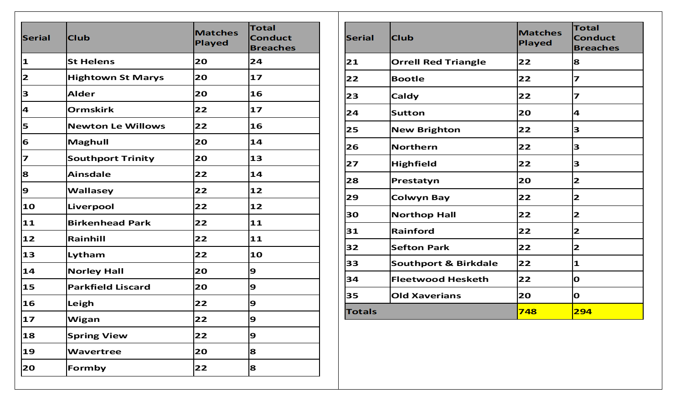

This data was examined with considerable interest. JW continued, if clubs wanted a breakdown overall of their own particular figures for the whole season - not for individual games - then these were available. Clubs should e-mail JW with a request for this, he would then extract it and send it to the club.

JW strongly congratulated both Fleetwood Hesketh and Old Xaverians CCs for their outstanding marks during the whole season i.e. “5 out of 5” on every occasion. He called for and received a sustained round of applause for these two clubs.

6.2 1st XI MCUA Pitch Marks

These were again based on MCUA umpire’s 1st XI marks over the whole season. Again there were 4 categories on which the pitches were assessed, each with a potential 5 marks in each of those categories in every game. Data was again projected as a .ppt.
in club rank order in the following table.

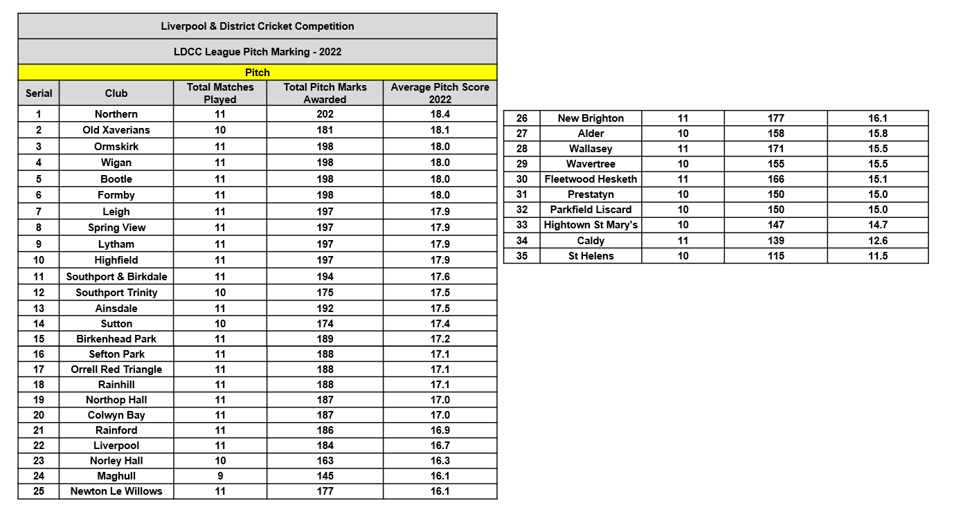

This data was also examined with considerable interest and JW repeated, if clubs wanted an overall breakdown of their own particular figures for the whole season – again not for individual games - then these were available. Clubs should e-mail JW with a request for this, he would then extract it and send it to the club.

JW repeated his thanks to Jim Hathaway for this magnificent data.

JW noted the Ground figures for Saint Helens Town above and noted that, during this winter, significant groundwork was being undertaken there. L&DCC was proud of the work that was being carried out as a result of consultation with the local Borough Council which had needed a little spark to set it in motion. L&DCC had provided that spark by commissioning an ECB Pitch Advisor’s Report (which had cost £450) and which had been instrumental in persuading the Borough Council of the need to carry out work on the square – which they owned.

We did not have a Club of the Year Award and perhaps we should, but if we did it would undoubtedly go to Old Xaverians in 2022 on the basis of their tremendous performances in all categories i.e. Fines, Pitch Marks, Discipline, Promotion etc. A website feature was likely on this. JW again called for a round of applause and there was again sustained applause for Old Xaverians.

7. Safeguarding

Liz Sinker was in temporary post here as Phil Green had felt unable to continue earlier this year. There will be nominations for vacant posts on L&DCC M/C in time for AGM 2023 for Chair, Secretary and Safeguarding Officer.

CW noted that we understood that the ECB/LCF arrangements for 2023 were the same as those in 2022 i.e. the dates were the same. There had been a marked improvement in the way that SHMS/Club Mark have been handled by clubs this year.

JW thought that all except two of our clubs had been Club Marked in 2022 and we knew about the details of those, they were still in progress. CW further noted that he was aware that there were no fewer them 26 categories that required an ECB disclosure and barring service checks (DBS), in short if a club wondered if a check was needed for a particular post it probably meant that there was! It really was essential to deal with all this as and when the need arose when officials changed posts in clubs.

On this note JW asked if clubs had all contacted their new LCF CDOs? It was vital that they did this just to establish the link. The new postings had recently been circulated to all clubs by L&DCC and by LCF and there were changes in personnel here as boundaries had been redrawn. These were the people who have the skills and responsibilities to help clubs the “nuts and bolts” of these processes.

LCF had some really good people in post, contacting them was very much to the advantage of a club.

8. MCUA

JW introduced Ian Lawrence (IL) the MCUA Chair.

“IL clarified some of the new laws from MCC e.g. saliva on the ball, replacement players, batters returning when caught, dead ball etc. that had come into force on the 1st of October 2022. Mankad dismissals had always been legal but were now incorporated into the Laws.

https://www.lords.org/lords/news-stories/mcc-announces-new-code-of-laws-from-1-october-2022

IL picked up on JW's earlier comments on MCUA umpires and agreed, we probably had the best set of umpires in Lancashire. In 2022 we had had no less than 10% of the National Panel Umpires standing in MCUA. Marks from clubs were improving. IL felt that progress was being made reflecting well on the education processes put in place by MCUA last winter.

IL did not agree with JW’s earlier comments in respect of the Lancashire League.

IL turned to the subject of MCUA fees in 2023. We were falling behind other leagues. £55 per match was much less than other leagues were paying, IL gave details. This would impact on retention of MCUA umpires.

MCUA would be running ECB ACO Stage 2 courses again in February and refresher courses for existing umpires in March. These courses would probably be at Ormskirk.”

JW replied to IL picking up on his reference to possible changes of MCUA Fees in 2023. JW understood that following M/C research, £55 was actually the second highest Umpire’s Fee paid in Lancashire in 2022.

JW set out the L&DCC Constitutional position over umpires fees. MCUA was a completely independent body and had no ability to propose fees to L&DCC at meetings. Umpire’s fees in the past had always been arranged after discussion between MCUA and L&DCC, the latter then making a proposal to an AGM. In the past umpires fees had been revisited on a 3-year cycle, latterly this had been changed to a 2-year cycle but high inflation this year meant fees would be reviewed again for 2023 giving us a 1-year cycle.

L&DCC too was hearing of payments in the Huddersfield league of £65 but the Northern League was only at £50 pounds in 2022.

A written request had been submitted recently from MCUA to L&DCC M/C for an increase in fees in 2023 to £80 each per game and a single-umpire game to £120. It had been stated that consultations had been carried out before arriving at this fee.

JW said that he wanted to take a risk here, he asked the club representatives present – the people who actually managed all the clubs in the L&DCC, “had anyone present here been consulted on umpires fees for 2023?” No one in the room had. JW made clear that he was also an umpire and, personally, most certainly did not want £120 as a single umpire fee.

Times were hard economically; we were all experiencing rapid rises in costs - the cost of food and beer was rising rapidly too.
We recognised there was a need to increase the fees in 2023 but L&DCC M/C had to decide on what should be put to AGM 2023, we intended to consult all our clubs.

9. Women's and Girls

JW introduced Paul Bate (PBa), the L&DCC W&Gs Executive Officer, who had been the driving force behind the establishment and great success of the L&DCC W&Gs structure in the last 3 or 4 years.

A .ppt slide was projected and PBa ran through the bullet points in detail.

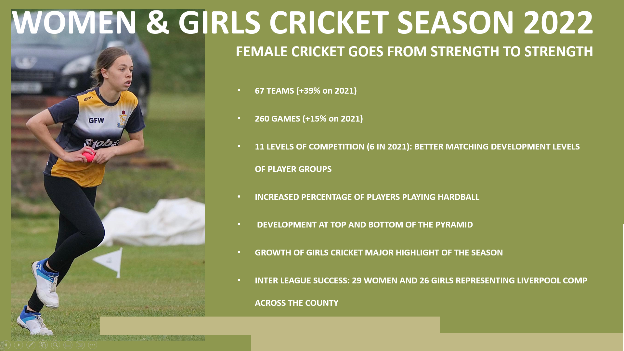

“The story again was one of success and one of growth and development across all areas.
Across the formats, 67 separate teams were fielded by our clubs, an increase year on year from 2021 of 39% with 260 games provided for - a 15% increase year on year.
We welcomed 5 new clubs in 2022 bringing the number of clubs with an active female section in our system close to 25.

11 LEVELS OF COMPETITION (6 IN 2021): BETTER MATCHING DEVELOPMENT LEVELS OF PLAYER GROUPS
An area we looked at in planning the competition structure for the season, was to improve game match up. We have a lot of players and teams who are at very different stages of development, so to mitigate this we introduced 2 levels for each competition - Development and Established - throughout the pyramid and we’re pleased to report this brought many more close games. Far better for development - and a more rewarding experience for those taking part.

INCREASED PERCENTAGE OF PLAYERS PLAYING HARDBALL
There was an uptick in players playing hardball, obviously something we want to see with players moving up the levels - or coming in direct for those returning to the game having previously played, and finding a new outlet, as is also happening.

DEVELOPMENT AT TOP AND BOTTOM OF THE PYRAMID
We are proud of how we have been able to provide opportunity and development at both ends of the pyramid…. from ENTRY LEVEL, 8 a side, softball pairs cricket for those new to the game, or still at an early stage of development, right through to former county players - both age group and full county - through the Women’s T20 League, our premier competition.

GROWTH OF GIRLS CRICKET MAJOR HIGHLIGHT OF THE SEASON
Of all the growth in participation across the female game in our league, special pride is reserved for the establishment of around 60 young girls coming together across the season to play games against each other, through a series of 5 Liverpool Competition Girls U10's Softball Festivals
The League is heartened to see so many clubs get behind this initiative, led brilliantly by Women’s and Girls Chair Liz Sinker, started towards the end of the 2021 season and continuing indoors in the winter at Toxteth Firefit, through funding from your League. A total of 7 teams participated, and all, towards the end of the season, were introduced to hardball through taster sessions delivered by volunteer coaches, helping to set the foundations for an U12 Hardball competition in 2023 which we are extremely excited about.

INTER LEAGUE SUCCESS: 29 WOMEN AND 26 GIRLS REPRESENTING LIVERPOOL COMP ACROSS THE COUNTY
We had an even better year on the Inter league front where 55 women and girls representing the League, took on counterpart teams across the county. We also secured for the first-time sponsorship for our teams through ELEVATE who provided for team shirts for our U12, U14 and Women/Open Age teams.
And they fared extremely well. The women’s team playing both T20 matches and a final 40 over game: Liverpool Comp Vs the Rest of the County, returned a 100% record with some quality team performances.
So, an outstanding season. Looking into next year we are about to survey clubs for their feedback as we build to our AGM in December and more definite plans for 2023.”

JW reminded the meeting that Paul Bate (PBa) had been the driving force behind the establishment and great success of the L&DCC W&Gs structure in the last 3 or 4 years.

There was warm applause for PBa.

10. Junior Leagues

RD projected the summary of the Junior League Division and Cup winners 2022 from the website.

U11 North Fleetwood Hesketh
U11 South Sefton Park
U13 North (Competition) Fleetwood Hesketh
U13 South (Competition) Oxton
U13 North (Development 1) Hightown St Marys
U13 North (Development 2) Northern
U13 South (Development) Liverpool
U15 North (Competition) Formby
U15 South (Competition) Liverpool
U15 North (Development) Hightown St Marys
U15 South (Development) Wavertree
U18 North Southport and Birkdale and Rainford (joint winners)
U18 South Wavertree
U11 Cup Wavertree (went on to become Lancashire Cup winners)
U13 Cup (Finals day) Fleetwood Hesketh
U15 Cup Formby (went on to become Lancashire Cup winners)

JW was very grateful to and named in turn the 2022 Junior Leagues sub-Committee, they were: Neil Crew, (Secretary) who worked abroad, Peter Roots, Chris Nutton, Mark Siddaway and Tim McKiernan (Coach).

JW ran through in detail the different types of competition and the structure of the Junior leagues.

It seemed likely that next season there would be two “halves” to the season, the first half would be geographically based, in the second-half teams would play each other based on team ability.

The Player Development Programme (PDP) 2023 had been finalised, clubs had been written to. L&DCC had now contracted with LCF to deliver a 10-week programme at Saint Bedes during January, February and March., LCF would be providing two coaches, L&DCC would provide a third. All players, both boys and girls, who had participated in the L&DCC inter league 2022 programme would be allocated a slot. This would be at a cost of 50% less to parents than that which LCF was charging at equivalent Programmes in other parts of Lancashire. The financial contribution from L&DCC would again come from club fines accrued in 2022.

The LCF inter-league programme in 2023 would be the same as that in 2022.

New clubs were coming into the L&DCC Junior Leagues system from Cheshire in 2023.

Birkenhead Park CC asked if there was any Indoor Cricket via L&DCC this winter. JW replied that this was an opportune question as ECB and LCF had emailed us recently asking about our arrangements for this winter. JW continued, we used to run such a programme but this stalled about three years ago because of declining interest and we had therefore stopped it. The costs for this could get quite high and was an ongoing problem but, if there was enough demand for this from clubs, we would look into it again.

11. Any other business.

11.1 Maghull CC asked who ran the L&DCC Twitter account and why was Paul McKenna still blocked? JW replied that M/C all did, he had no idea of the basis for the blocking and would look into this.

11.2 Whitefield CC asked if provision for teas would remain the same in 2023. JW noted that this had been voted on at AGM 2022, clubs having voted there by 26 to 6 votes that the provision of teas should not be compulsory in L&DCC; there were no plans to put this to the vote again in 2023. Clubs could of course provide teas if they wished to in consultation with their opposition and our regulations would be the same in 2023.

There were no further items of AOB.

12. Notices

12.1 MONDAY 28TH NOVEMBER at 7.00pm 3RD XIs CONSULTATION MEETING BY ZOOM.

12.2 TUESDAY 10TH JANUARY 2023 L&DCC AGM AT FIRWOOD-BOOTLE CC at 7.00pm.

CW thanked representatives for their attendance and wished them all a safe journey home and closed the meeting at 8.29pm

