Firstly, thank you once again for signing up to host a Women’s Soft Ball Cricket Festival this summer! We’re really looking forward to working with you to make your Soft Ball Festival the best it can be, which is why we’ve made this handy guide – to supplement the training course and make sure you can plan and deliver your Festival with ease…

Why Women’s Soft Ball though?

When asked what they’d like to see from an alternative cricket offer women stressed the following four things…

FUN | FAST | SAFE | SOCIAL

Hence the Soft Ball Cricket Festival format was born! If you’ve never been to or seen a festival before, the day takes the form of many pairs cricket format games using bespoke Soft Ball kit. There’s a conscious effort to focus not just on cricket, hence the festival atmosphere we’ll come on to later.

This guide is designed to tell you everything you need to know about Women’s Soft Ball and how to make your festival a success, but if you need any more information or have any questions, please get in touch either via email (a.behrens@yorkshirecb.com) or mobile (07860885058).

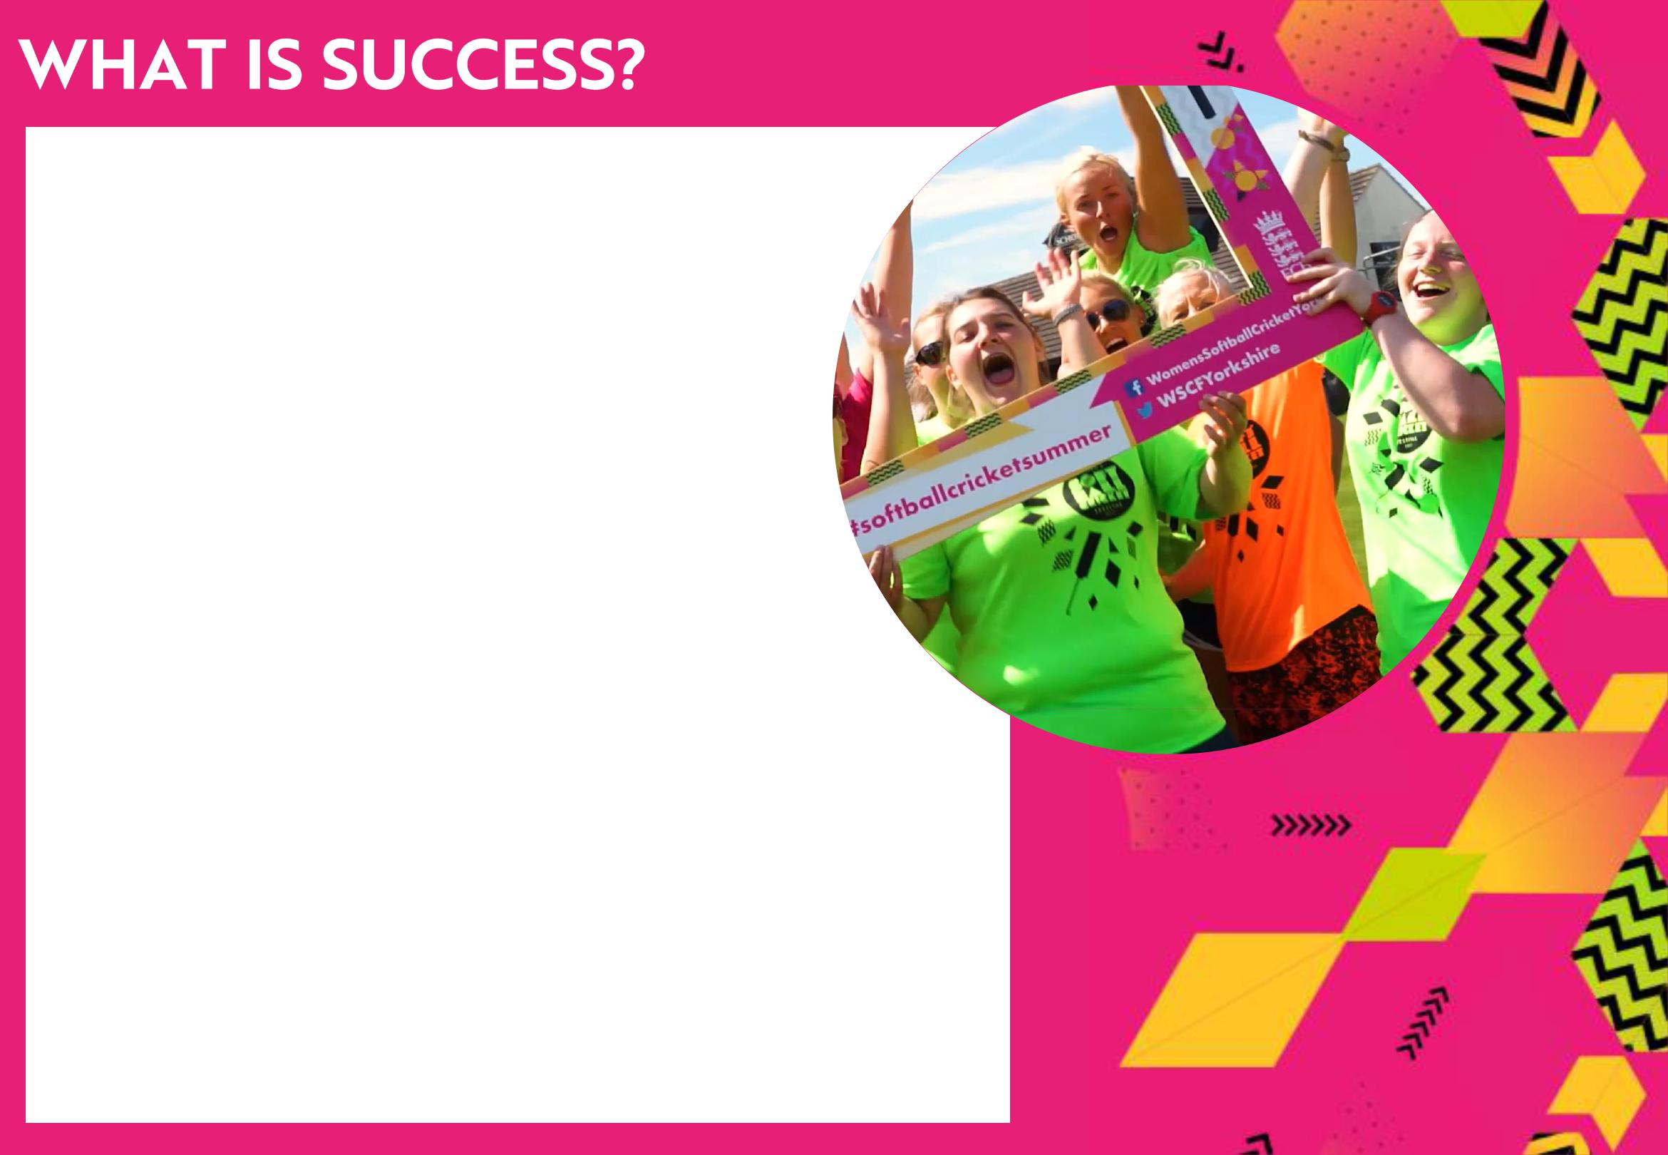
A successful Soft Ball Festival leaves everyone with a smile on their face – even the organisers! Follow the advice in this guide and get as many people as possible on board to help and you’ll find running

a Soft Ball festival at your club a piece of cake!

The environment and atmosphere at your festival should be one focussed on fun and socialisation. We’ll come on to rules later, but the emphasis on The games is making sure everyone gets a go and feels a sense of achievement, so it’s ok to be relaxed and give lee-way where possible! We want the Soft Ball Festivals to show cricket off in the best possible light to new participants, with plenty going on at the club both on and off the pitch!

A great event is one where there’s loads to get involved in, from cricket games ensuring as many people as possible can play at any one time, to refreshments, leaving people with a great impression of your club and the game of Soft Ball so that they keep on coming back for more…

As Soft Ball Hosts, we ant to work with you to organise and plan your festival, making it clear what we need from you as well as what we will help out with. Included in this pack is a document setting out exactly what we expect from you guys and what we will do to make the process as easy as possible.

We need your help…

As well as organising the running of the festival itself and volunteers to help out on the day which we’ll cover in more detail later, set some time aside to getting teams of women from your club signed up to play on the day!

We’ll help you to communicate with those signed up to your festival prior to the event, but on the day it’s down to you to keep the communication going, and in the run up to the event to make sure everyone in your club knows what is going on.

Again we’ll help you with promoting your event, but if you could spread the word to

everyone you know within and outside your club then two voices is better than one!

Make sure everyone who comes along to your festival feels welcomed, both by you, other volunteers from the club and the atmosphere on the day.

Once the day is over make sure you bring everyone in to celebrate the days cricket, whether you want to award prizes or not!

Before the day of the festival arrives, it’s crucial you make sure that you’re ready and raring to go by sorting out the following…

- The first thing you need to do is put together a plan, which I’ll help you with by providing a template and talking you through the information required, detailing what you need to do between now and your festival date

- This plan needs to include sourcing volunteers to help you both on the day of your festival and in the run up, something we’ll cover in more detail later on in this guide

- It’s a good idea to have a big group warm up planned! Will share videos of examples of these with you over the coming weeks.

- As part of this plan, we’ll put together a plan of action for promoting your festival, your responsibility will be to spread the word about your festival to those within your club through email templates and posters provided

- If you have social media it would be great for you and those within your club to share the event on Facebook and spread the word to all those nearby whom you know and might be interested in attending the festival

- In promoting your festival, you’ll receive a custom booking link that you need to encourage everyone attending to complete, I will have access to this system to see who has signed up to your festival and will share this with you on a regular basis

- While promoting your festival, get together a group or two of women from your club to make up a few teams!

- Finally, if you’re looking to incorporate any of the festival extras mentioned later on the day, this also needs to be sorted prior to the event!

At many of the festivals held around the county and the

country last year, the cricket wasn’t the only draw for

the women in attendance of the festivals. We recommend that you get a BBQ or some form of food offer going on the day as well as music playing in the background, but there’s loads more that can be done! In order to create that fun festival

atmosphere, it might be worth considering some of the below options used during last years festivals…
- Kids Zone

- Food Stalls

- Face painting

- Bouncy Castles

- Fancy dress

- Tug-of-war finale

- Prosecco or other alcohol themed events

- Jewellery Stalls/Inviting other local businesses down

- Raffle to raise money for charity or the club

These are just some options already tried, but be as creative as you like in order to make your festival stand out from the crowd!

When it comes to the day of the festival itself, you job first and foremost is to ensure everyone in attendance has a

good time! From welcoming them at the ground, to celebrating the success of the festival at the end of the day, make

sure the focus of the festival is on fun!

While you’ll have an idea of how many people will be coming to your festival from the CVENT registrations sent to you

prior to the festival beginning, some people may turn up on the day who haven’t pre-registered. This is fine, however

before they start playing ensure they fill in one of the sign up cards provided before playing. To ensure this

is the case, register everyone who arrives using the data retrieved from CVENT to find out who has turned up without

signing up before hand. Keep these cards safe, as you’ll need to get them back to me upon completion of your festival.

Once you know exactly who you have, you can set about organising playing logistics on the day. It’d be good to have a

rough plan of who plays who when before you arrive on the day but note that this may change depending on how many extra people turn up!

- Some teams may be uneven and may not wish to move onto another team to make numbers equal. This is completely fine, you just need to make sure that fielders are rotated throughout the day and that the number of overs each team faces is the same.

Volunteers need to be briefed before people start arriving, so they know what their roles are on the day. If they’re umpiring/scoring, make sure they know how to do this using the guides provided, and make sure they know that the emphasis needs to remain on having fun as opposed to what is ‘correct’. Bowling underarm is fine, and if the participants need to take a step closer to the stumps that’s also ok – it’s about ensuring that everyone is given the opportunity to succeed, both when batting and bowling. Before participants arrive it’s also key that everything is set up and ready to go, particularly the pitches. Pitch dimensions are similar to U9s size pitches – pack as many of these as you can onto your ground to ensure as many people as possible can play at once.

Finally, if you’re providing any ‘Festival Extras’ on the day, make sure these are also set up and ready to go before the

Women arrive ready to get playing!

Once the festival is over it’s vitally important you pass on the details of anyone who attended your festival but wasn’t listed on the CVENT registration list sent to you by us prior to the festival starting.

Of the kit you receive, you’ll get one kit bag to keep, but the other needs to be packed up ready for us to take away, along with any t-shirts not used on the day so that we can use them to help other hosts out who are running low on t-shirts.

If you want to be able to contact the women who attend your festival after the festival has finished, get in touch with me! When the women sign up they have the option to opt in to hear more information about Soft Ball cricket opportunities from me so I can pass on any information you might have. If you want to contact them directly, then this is something you’ll have to gain permission and contact details for from the women on the day.

If you want to provide more opportunities for women to play at your club following the festival, here’s some top tips to creating the right offer…

Everyone gets involved in a relaxed, informal way. Introduce new skills but keep it simple with small sided games and pairs formats.

Between 30 and 60 minutes.

Soft Ball Cricket is ideal for introducing new groups to the game without fear of injury. You also need to offer a safe learning environment that builds confidence and doesn’t judge.

Women want time to chat and enjoy learning and challenging themselves together. Deliver sessions where the women can support each other.

Getting as many volunteers from within and outside the club involved on the day is the key to

making your festival a success! The more people you can get on board the easier the organisation and running of the festival will be. Here’s just a few examples of people you can get to help at your festivals this summer…

- Club members to help spread the word about your festival, not just within the club, but to any contacts they may have outside the club

- Volunteers to help umpire and score the pitches

- People to help set out the pitches at the beginning of the day

- People to run food stalls, BBQs, look after the bar

- People to oversee any festival extras you may be having

- Someone to take pictures and videos at the event

- Qualified First Aider

Almost anyone can fulfil any of the above roles, but it might be good to start with those who already volunteer or play at your club to see if there’s any willing helpers just waiting to be asked!

In terms of extra support from us,

We’ve included a document within

This pack detailing just what you

Can expect from us, but to go

Over it again you’ll receive…

- All the kit you will need to run your festival, initially two kit bags, one for the club to keep, but if we can see from CVENT you will need more we’ll make sure we get this to you

- We will oversee the CVENT sign up system, providing you with regular updates

as your festival gets closer to ensure you know what to expect on the day

- This pack is part of our support for you, if there’s anything else you think should be included then give us a shout!

- We will aid you in the promotion of your event, through our Women’s Soft Ball Cricket Festivals page and County Board social media

  - We will provide you with all the promotional template and

materials you could dream of, but again, if you think there’s

anything missing just give us a shout!

      - You’ll receive a pack of t-shirts for all your festival participants to enjoy
    - We hope to make sure a
member of staff is on hand at each of your festivals, however if this won’t be the case we’ll let you

know within plenty of time

- Free training for a softball activator from your club to help them with this process
- Plus we’ll be on hand throughout the process to help answer any questions you have or aid you in any way we can!

- Date and time of festival confirmed

- Attended a Women’s Softball Activator Training session and completed Action Plan

- Information about the festival distributed amongst all club members

- Information about the festival distributed to everyone you know outside of the club who may be interested in attending the festival

- A team from the club organised to play in the festival

- Volunteers identified to help with the running of the day

- Festival extras decided upon and booked in/confirmed

- Pitches marked out prior to arrival

- All volunteers briefed and aware of the role they must fulfil and how to do this

- Festival extras set up ready for the women to arrive

- Welcoming and signing in of participants, including getting anyone not registered previously to fill in their details

- Mass warm up upon completion of registration

- Plan for each of the pitches finalised once you know how many extras you have arriving on the day

- Pictures and videos of the festival taken and stored ready to be shared with us and your club

- Celebration of the day at the end of the games

- Share the information of anyone who turned up on the day, plus photos and videos from your festival with us

- Outline a soft ball offer for women at your club if one does not already exist

