L&DCC 1st XI Behaviour 2022

MCUA umpires award 4 sets of team “Behaviour Marks” - each out of 5 - every time they umpire a 1st XI game. Any mark of less than 5 shows the umpire’s view that the behaviour in that category had been less than exemplary. All these “less than 5 out of 5-mark occasions” had been collated below. A mark in the following tables of say “10” means that there were 10 such breaches of best possible behaviour by that 1st XI during the whole 2022 season
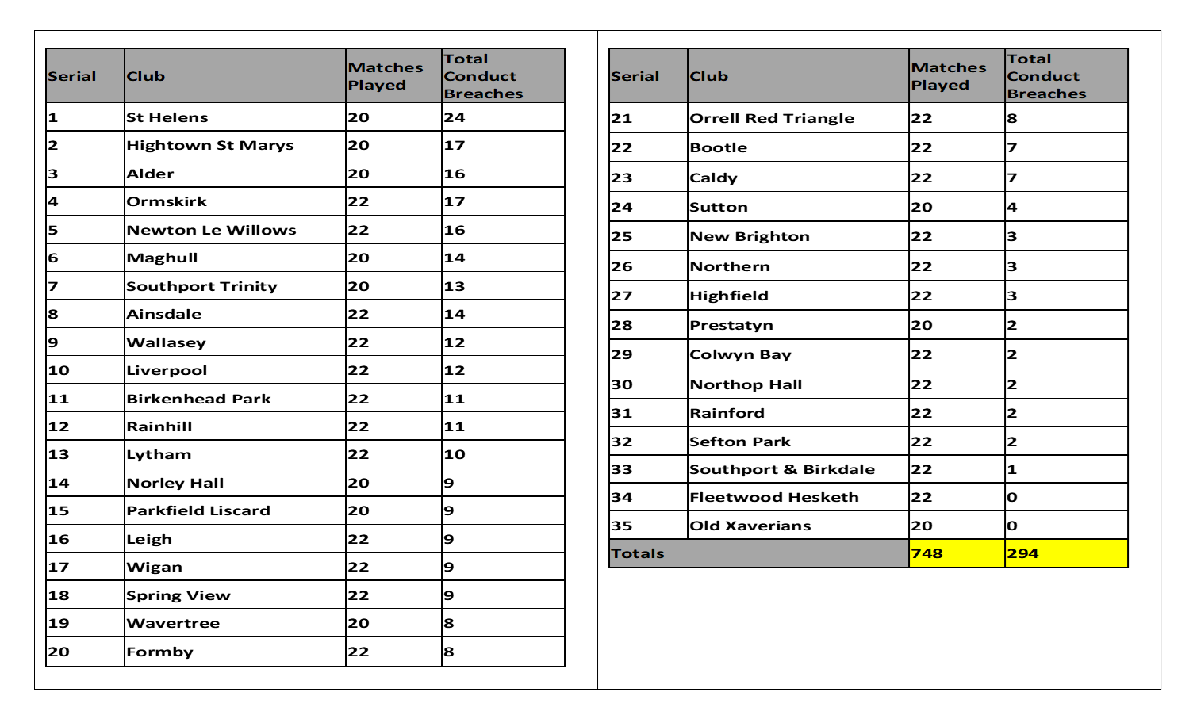

L&DCC Pitch marks 2022

These are again based on MCUA umpire’s 1st XI marks over the whole 2022 season. Again there are 4 categories to assess the pitch (Bounce/Carry etc) and each has a potential for 5 marks in every game.

